The histories of an enlightened ruler: Malam Muhamman Bitemya Sambo, Garbosa II of Donga, Central Nigeria
Richard Fardon and Graham Furniss, with additional photographs provided by Bobga Bobzom

Abstract Muhamman Bitemya Sambo (1902-82), who became Garbosa II, the seventh Gara Donga (1931-82), took more than thirty years to complete a history of his own Chamba people in 1956, Labarun Chambawa da Al’Amurransu. Garbosa II’s successor, together with representatives of his descendants, have graciously permitted an English translation to be published. This essay introduces that English version, provides it with context, and addresses the challenges of translation.

Resumé Muhamman Bitemya Sambo (1902-82), devenu Garbosa II, le septième Gara Donga (1931-82), a travaillé pendant plus de trente ans pour compléter une histoire de son propre peuple Chamba en 1956, Labarun Chambawa da Al’Amurransu. Le successeur de Garbosa II, ainsi que les représentants de ses descendants, ont gracieusement autorisé la publication d’une traduction anglaise. Cet essai presente cette version anglaise, lui fournit un context et aborde les défis de la traduction.

Tsakure Muhamman Bitemya Sambo (1902-82), wanda ya zama Garbosa II, Gara Donga na bakwai (1931-82), ya yi fiye da shekara talatin kafin ya gama rubutun tarihin Chambawa cikin 1956, watau Labarun Chambawa da Al’Amurransu. Mabiyin Garbosa II, tare de wakilan zuriyarsa, sun ba da izni a buga wata fassara zuwa harshen Ingilishi. Wannan mak'ala ta gabatar da wannan aikin fassara, ta ba da bayanin muhallinta, ta kuma tattauna wasu daga cikin wahalolin fassarar.

The histories of an enlightened ruler: Malam Muhamman Bitemya Sambo, Garbosa II of Donga, Central Nigeria
Richard Fardon and Graham Furniss, with additional photographs provided by Bobga Bobzom
Introduction
Chiefs are busy people, so a colonial chief finding time to write the history of his own people is unusual, and more remarkable when the history he composed sheds light on an anarchic period of the nineteenth century about which few testimonies were recorded. The chief’s initial research predated his accession and was augmented over more than three decades as other demands allowed and his enthusiasm dictated, a pattern of attention which accounts for the occasionally recursive character of the finally published text to which episodes were added when there was a moment to do so.
I said that I would not have the opportunity to describe all the wars of the chiefs of Donga on this occasion because of the weight of administration upon me, but nevertheless, now that I have a little spare time let me relate the story of the Bayaro war. (109)
Later a supplementary volume was indeed added to fulfil the author’s wish on completing the first.
Were it to be possible, were the sum of my life in this world not to be over, and one day I had the chance to write another book that would be useful for the Northern Region, and yes, even for the whole of Nigeria, then I would be the happiest person alive to be able to do that. (129)
These two works can be appreciated in several ways, in conclusion we shall offer some thoughts about the challenges of their translation from Hausa to English, but we begin with the two most obvious readings: as histories of the events they recount, and as contemporaneous evidence about their author and the time of their composition. Given that the writer and his context provided a lens through which his history passed, the second reading will influence the first. So, we begin with the author, about whom we know largely from his own account.
Garbosa II, the regnal name of Malam Muhamman Bitemya (elsewhere in the text spelt Bitenya) Sambo, the seventh Gara Donga, or chief of the Donga chiefdom in central Nigeria, was the author in Hausa of two volumes: The History and Customs of the Chamba (Labarun Chambawa da Al’amurransu) and, later, The Family Trees of the Chiefs of Donga (Salsalar Sarakunan Donga), which were completed in 1956 and published together shortly thereafter. In what follows, we refer to these two texts for short as The History and The Family Trees. Garbosa tells us, with the precision characteristic of a diarist for the significant dates of his life, that it was on 21 August 1923 that he began research for the first of these books by seeking permission to speak to the elders from the then chief, Garbasa II, his paternal cousin (FeBS) and classificatory brother, who had become the sixth Gara Donga two years earlier in 1921 and would reign for ten years (66). The names of Garbosa’s most important informants, some of whom might still be recognizable to people in Donga, are provided in his introduction and in a single reference later.
Well, here are the names of the most expert in helping me, both men and women, while I was writing this book: Moya [this named shared with a son of Gargbanyi, see also 137. 139], Nganang, Burba, Nawalam, Mr Ventujol a Frenchman, and a professor whose name is Mallam Mohammed, a Kanuri man. Amongst the women there were Gambarga, Pinkina and Konyo-a. (66)
This is known through extensive historical researches, and there was a very old Chamba man called Livom, son of Popsinworga, one of those that I have encountered who spent most years on this earth, this man was alive from the time that Garbasa Nubumga Donzomga went to Bauchi [the mid-nineteenth century], and it was he who said that the Jukun claimed that the Chamba raided them during the reign of Aku Kuvyon Angyu. (104)
Supposing, like Livom, that others of Garbosa’s informants had been in their seventies or eighties in the early 1920s, then they would have had first-hand experience of the events of their childhood from the middle to the early second half of the nineteenth century and as adults witnessed events from, say, the 1870s onwards.
Garbosa II
To begin with our author, who as chief is also one of the protagonists of his own narrative: Muhamman Bitemya Sambo was born in 1902, the seventeenth son (in his listing of them) of the fourth Gara Donga, Garbosa I (reigned 1892-1911), and grandson of Nubumga Donzomga, the second Gara Donga, titled Garbasa I, after whom Donga was named in circumstances we shall examine later. His mother was Aminatu Bagalambiya, a relative of warriors given by the Emir of Bauchi to support Nubumga Donzomga’s campaigns. Although his father and mother were both Muslims, the boy was educated by the presbyterian Sudan United Mission (henceforth SUM), for which a mission house had initially been built beside the Donga marketplace in 1907, where the first ‘regularly organised Church was brought into being’ in June 1917 (Maxwell 1954: 65-66, 125-26). The future Garbosa II was shaped by the cutting-edge developments of the early twentieth century in West Africa: European conquest and colonialism, the First World War and the invasion of German Kamerun, and mission education; and he grew into adulthood during the heyday of British indirect rule in central Nigeria in which he played a part, witnessing the technological innovations of the time.
When Capt. F.H. Ruxton’s submitted his 1908 Muri Annual Report (para 33 & 34a) Christian education was in its infancy.
The American section of the Sudan United Mission have held 111 school sessions at Wukari and 160 at Donga, the average attendance being 7 and 18 respectively.
Reading and writing Hausa in the Roman character, arithmetic, elementary geography, physiology and hygiene comprise the school curriculum.
All instruction is given in Hausa. The primary purpose of the Mission is to educate boys for the native ministry.
Attendance at school is practically paid for, i.e. the Mission pay their scholars, a most demoralising system and one from which no good can result. The payment is made I understand nominally for certain petty services performed but actually as the only means of inducing the ‘scholars’ to remain in touch with the school – a marked contrast to the desire for education shown by those attending the Moslem Schools
[….] The Sudan United Mission … have stations at the following places, viz Ibi, Wukari, Donga, Dampar, Wase and Langtang … Their work is evangelistic, educational and medical. They endeavour to save the individual native’s soul instead of influencing the mass towards higher things.
Bitemya Sambo’s formal education began, he writes, at the age of eight or nine, in 1910-11, so just a couple of years after Ruxton’s jaundiced report and perhaps not accidentally coinciding with his father’s death in 1911. The boy had been entrusted to relatives.
He [Garbosa I] drew to himself the children of his elder brother Gargbanyi [his predecessor as chief], yes and including those on the mother’s side (children of an uncle) and trained them up. His own children were cared for and raised by his brothers. This is how it was done in those days, the children of your relative are yours, and your children go to your relatives. (139)
A cautionary episode during the First World War, which the older Garbosa recalled vividly, occurred only a few years later, around 1914-15 at the height of the local phase of the war around Takum (Fremantle 1922: 69-71).
During the German war [...] people brought false accusations against Garkiye II [the successor to Garbosa I, who reigned 1911-21], saying that in most towns any news of Germans approaching would produce general flight, but the people of Donga took no notice, and the reason was that their chief was working with the Germans. Goodness me, it was an entirely spurious accusation, the Germans had never headed for Donga so there had never been a need to flee. Well, European military officers deal in life and death and don’t have the aptitude for careful investigation as District Officers do, let alone are they able to recognize when something said is hypocritical nonsense. The soldiers took Garkiye II to Suntai and then to Takum. On the first journey to Suntai, it was me Bitemya Sambo who carried his chair. They collected workmen from the barracks and told him to accompany them. Garkiye II and Abi, and me as a small boy, were concerned to be part of such a war party. At that time, no pity was shown nor any regard for the law, all was chaos. Later, provisions were brought to us on horseback, but Garkiye II refused all of it, he refused to mount a horse he was so downcast, he would have preferred death at that moment. On that journey even women had been taken and made to carry loads. On the road Atambui died he was beaten so badly, and he was cast aside, and our people who came after buried him in an anteater hole. Many people vomited blood and shook because of the beating by the soldiers and the overseers! Such heavy loads and so much beating.
After they reached Suntai […] Garkiye II returned home but before long more trouble arose over forced labour. Garkiye II had to leave again, he was taken to Takum. What a journey that was! They even went into the palace and seized the wives and made them carry loads. A tall European military officer and his agents, after they had entered the palace and captured the women, arrested Gbana Gamuga and tied him up and took him to Takum! War had come to us and it was not from the Germans! Dear oh dear! Major A. E. Churcher, who had appointed Garkiye II, was the District Officer, and he was at Takum at that time, and he took Garkiye II out of the hands of the military officers. He released him and said he should return home, along with Gbana Gamuga, and they came home together. The wickedness of government messengers was notorious at that time. (147)
By this time, at the age of thirteen, Garbosa was able to ‘read a few books’, then:
In 1916, when I was fourteen, I entered the service of Rev. C.L. Whitman. I was the senior boy, Umaru was next and then Bitema [Bintema] followed after. We were having classes and I was better than the rest, so much so that I was given a few boys to teach. Between 1918 and 1919 I became a teacher. (152)
At the beginning of 1918, the young Malam Sambo accompanied the Rev. C.L. Whitman and his wife to Lokoja, Baro and Minna on their way to the USA on leave. After a couple of adventures trading kola nuts and buffalo hides, he next attended the ETC (Itisi in its Hausaized version) run by the SUM to train as a teacher. Whitman then sent him to the Lucy Memorial School in the nearby Jukun capital of Wukari (which commemorated Lucy Eveline Kumm, the wife of the pioneer of the SUM, Dr H. Karl W. Kumm, who had died soon after arriving in Nigeria).
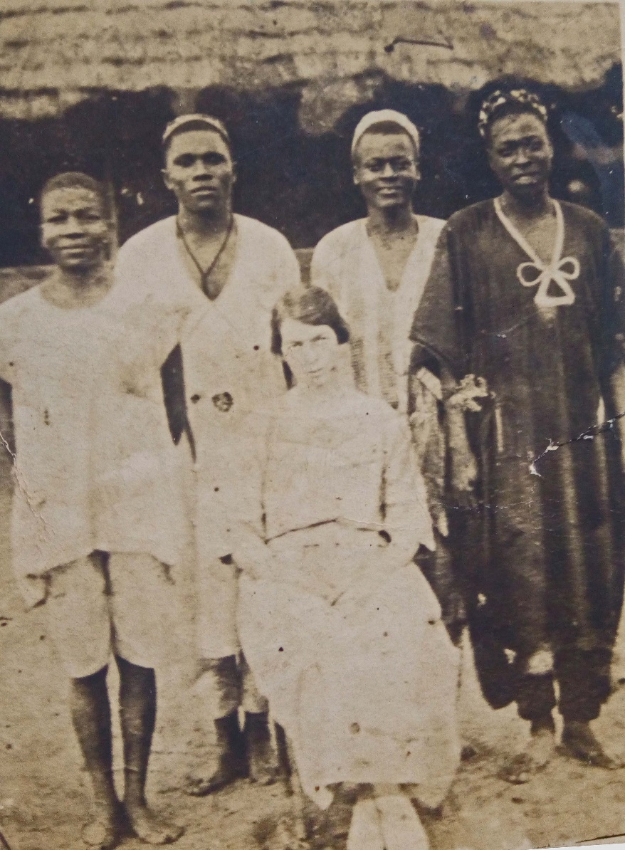
Photograph 1 From left to right standing – Malam Bitemya Sambo (the future Garbosa II, 17th son of Garbosa I), with his brothers Malam G.B. (Bondinga) Umaru (18th son), Malam G.K. (Garkulyebiya) Atiku (20th son), and their paternal cousin Bintema (Bitema) the son of Sama and grandson of their common grandfather Nubumga Donzomga. Seated in front - possibly Miss R.M. Rimmer; photograph probably taken between 1922-1925 (given the presence of Atiku, who Garbosa notes joined them in 1922, as well as Garbosa and Umaru, who left school in January 1925).
Of this he said:
They taught us all the subjects that are covered in the curriculum including the speaking, reading and writing of English. In October 1920 I went to that school [the Lucy Memorial School] for the school year 1921. Umaru also came [his next younger brother; an 18th son of that name is listed by Garbosa immediately after himself]. We worked hard and put up with everything […], and we surpassed all of them and were awarded the Grade 3 Certificate on 14/2/23. I was at school with my brother until we left in January 1925. I was four years and four months in the Lucy Memorial School altogether. Malam Atiku found us at that school in 1922 and we finished our schooling along with him. Since 1916 and our circumcision we three have been inseparable. Our ways are the same and nearly all our opinions are the same, and we were never divided, just like Nyaga, Samvala [Sanvala] and Gariya [Garpiya], the sons of Gargbanyi. Even now our affection for each other has never diminished. (152)
In 1923, I and M[alam]. Umaru accompanied Miss R.M. Rimmer, our teacher, to Port Harcourt on her way to England on leave. (154)

Once qualified as a teacher, people addressed him as Malam Sambo. The young man’s personal qualities gained him trust widely: from the missionaries (Malam Sambo’s baptism in the River Donga had taken place on 29 December 1920, four years after his traditional circumcision), from British colonial officials, and from his own people.
The future Garbosa II continued to grasp opportunities presented to him to see more of Nigeria. After accompanying Miss Rimmer in 1923, he undertook further trading trips in Nigeria with his brothers in 1925, on return from which Captain Warren, then the Assistant District Officer, paid him and his younger brother Malam Umaru, also become a teacher, to conduct a survey of Donga country and write it up in the then District administrative centre of Ibi. He must have acquitted himself well: when in 1926 the government anthropologist C.K. Meek visited Donga, Malam Sambo was paid to write out the seasonal round of events in Donga, and Meek was sufficiently impressed to ask for him to continue to help him in Wukari with his work on the Jukun. Garbosa relates that the SUM missionary and later chronicler of its history, J. Lowry Maxwell, took him to Wukari on his motorcycle on 8 January 1927, where Meek enlisted him as an assistant on 18 January 1927; together they journeyed as far as Yola in Adamawa via Jalingo, the capital of the Muri Emirate, and on to the Bachama chiefdom of Numan, which was the Danish SUM’s regional headquarters. Six months spent in Adamawa took Malam Sambo as far south of Yola as the Verre Hills (but apparently not the short distance further south to visit the Chamba living there). Returning, he and Meek reached Kaduna Junction on 10 September 1927, where Malam Sambo was released from service at his own request and travelled home after seeing the cities of Kano and Zaria and bidding farewell to Meek in Kaduna. Meek had apparently taken a shine to the younger man who, for his part, wrote that he learned much from their nightly discussions. Their researches were published in 1931 by Meek in the two-volumes of Tribal Studies in Northern Nigeria, which included chapters on the Verre and Chamba (predominantly those of Donga), and in the Jukun monograph A Sudanese Kingdom, although, as was then the convention, without acknowledgement of his assistants in either case. The second of these books had been prompted by Governor Palmer’s scheme to revive what he considered the departed eminence of a lost Jukun empire of Kororofa, so that the Jukun could act as indirect rulers on behalf of the British (see also below). A passage in Garbosa’s book appears to respond in some bemusement to the attempt to involve Chamba in the events of earlier Jukun history, given that his own evidence only supported there being a Chamba presence in the Benue plains after they had been displaced from their homelands in the course of the nineteenth-century Fulani jihad in Adamawa (104-5). Garbosa’s hesitations in this regard remain valid given the lack of solid evidence underpinning later attempts to allot the Chamba a decisive role in the demise of the Jukun Empire of Kororofa (e.g. Mohammadou 1978, 1999). It may have been around the same time that Malam Sambo became aware of the nature of the ethnographic research carried out by Captain R.M. Downes, to be published in 1933 as The Tiv Tribe by the Government Printer in Kaduna (cited by him twice: 105 &128).
The future Garbosa’s work for the colonial government resumed on return from his travels with Meek. Meeting up with Captain Best, he started work at Ibi and was sent back to Donga where he completed another (apparently second) survey, again with his brother Umaru. On 5 June 1928 (as Garbosa scrupulously notes), R.M. (Rupert) East, the Provincial Superintendent of Education, took him to open Wukari Elementary School, where he was subsequently joined by Malam Umaru, who was shortly sent in 1930 to open Takum Elementary School. Then, on 15 November 1930, Donga Elementary School was opened under his younger brother, Malam Atiku, who had previously succeeded Malam Umaru as District Scribe. The introduction of education was a family affair: based in Wukari, Malam Sambo oversaw the schools in Donga and Takum run by the two brothers who had been his constant companions. As he would later sum up:
When it came to spreading modern education in this country, the Chamba provided huge assistance in establishing Native Authority (NA) schools. I who am writing this little book was an initiator. When the Government started to open NA schools, I and Malam Umaru (now [1956] at Government Vocational Training (VT) in Gboko) and Malam Atiku, NA scribe, we three were sons of Garbosa I, and we three opened the Division schools here. And you will find many products of the Mission schools whom we taught right from the Mission house. And now our work has progressed enormously at a speed that we could never have imagined at that time! And so, we thank Allah the creator when we remember that we were amongst those who accelerated the progress of this country. (128)
When, on 5 August 1931, Garbasa II died, Malam Sambo was chosen by both the ‘senior and ordinary people’ to succeed him. In the last of several succession tussles that Garbosa documents, a merchant called Karmiya had tried to stake his claim to be included among the candidates for chiefship, but District Officer Emberton threw him out when, in response to questioning about his family connections to the throne, he revealed he was ethnically a Kentu from Nukpo. On this occasion at least, the British upheld the hereditary principle that the chieftaincy remained within the Chamba ruling family, in the Donga case, the Sama.
Captain J.J. Emberton, District Officer in charge Wukari Division (who became Resident in 1936), presented me to the people according to our Chamba customs with the agreement of the Governor. On Wednesday, January 27th 1932, the Resident Mr E.S. Pembleton came to Donga accompanied by DO Cpt. J.J. Emberton and DO Cpt R.M. Downes, and the Resident confirmed my chieftaincy and awarded me a staff of office with a crown on the top, third-class, on the orders of the Governor. (153)
Chiefly responsibilities now prevented Garbosa from devoting as much time as before to his historical writings, but he brought them up to date in 1932, and in 1933 a version was apparently made available in some form, although we have not seen a copy of it. This version may have informed a brief report Garbosa wrote in 1935 at the request of the colonial administration that dealt with the relations between the immigrant Chamba, their allies, and the local Kentu, one of whom, Simon Attajiri, was proposing separation from Chamba administration. Dewar notes in his main Report,
The intelligence and aptitude of Garbosa (Garboshi) the present chief of Donga is illustrated by his report on the administration of the Kentu, a translation of which from the Hausa is appended to this report … Beyond a verbal outline of the kind of information required, he was given no assistance nor had he the advantage of studying other reports as a model. His work is, I therefore consider, worthy of high commendation. (Dewar para. 4)
Similar sentiments are echoed in the Acting Resident, Emberton’s covering Report,
His honour will be interested to read the notes on the Kentu people by the present Chief of Donga whom he met recently at Kaduna, whilst on an educational tour. In parenthesis I may add that I hope shortly to submit an account of his tour written by the Chief from his diary! […] The present chief, Garbosa, is a Christian and a man of considerable intelligence and enlightenment. A report written entirely by him on the Kentu … is, I think, a praise-worthy effort. (Emberton paras 3& 5)
The British comments may have been disingenuous. Dewar, and particularly Emberton whom we know to have been present at Garbosa’s installation, are unlikely to have underrated how keenly Garbosa’s earlier experience informed his sense of colonial expectations when it came to justifying benevolent rule. Dewar’s suggestion was eventually endorsed, and the administrative position of the Kentu remained unchanged.
The present chief of Donga is very enlightened, sympathetically inclined to his subject peoples, and can be safely entrusted, under the guidance of administrative officers, to respect the customs and traditional organisation of the tribes committed to his charge. (Dewar para. 36)
Garbosa was in his own estimation and in his deeds a modernizer, though one attentive to traditional etiquette. We comment later on the contrasts he draws in terms of the present time (zamani) and the time of ignorance (zamanin jahiliyya).
In 1933 a new dispensary was built with fired bricks and a metal roof. In 1934 a fine new court room was built with a metal roof, and the walls were plastered with cement. (154)
Whenever the chief appeared in public, Kpandilgshi would tend to the clothes he was wearing when he went out, and if he saw that there was something that was not quite right about his turban or to do with the ornaments on the chief’s body, then he would go up to him and tell him what he had seen about his clothing or adjust it to make it better. (86)
When he succeeded to the chieftaincy of Donga as Garbosa I [Garbosa II’s father], he was better than any deceased chief in the art of turban winding. Here in Donga we thought it was Garbasa who learnt turban winding from his journey to Bauchi, but who knows! We cannot know now, but we are sure that it was not an original Chamba custom. (138)
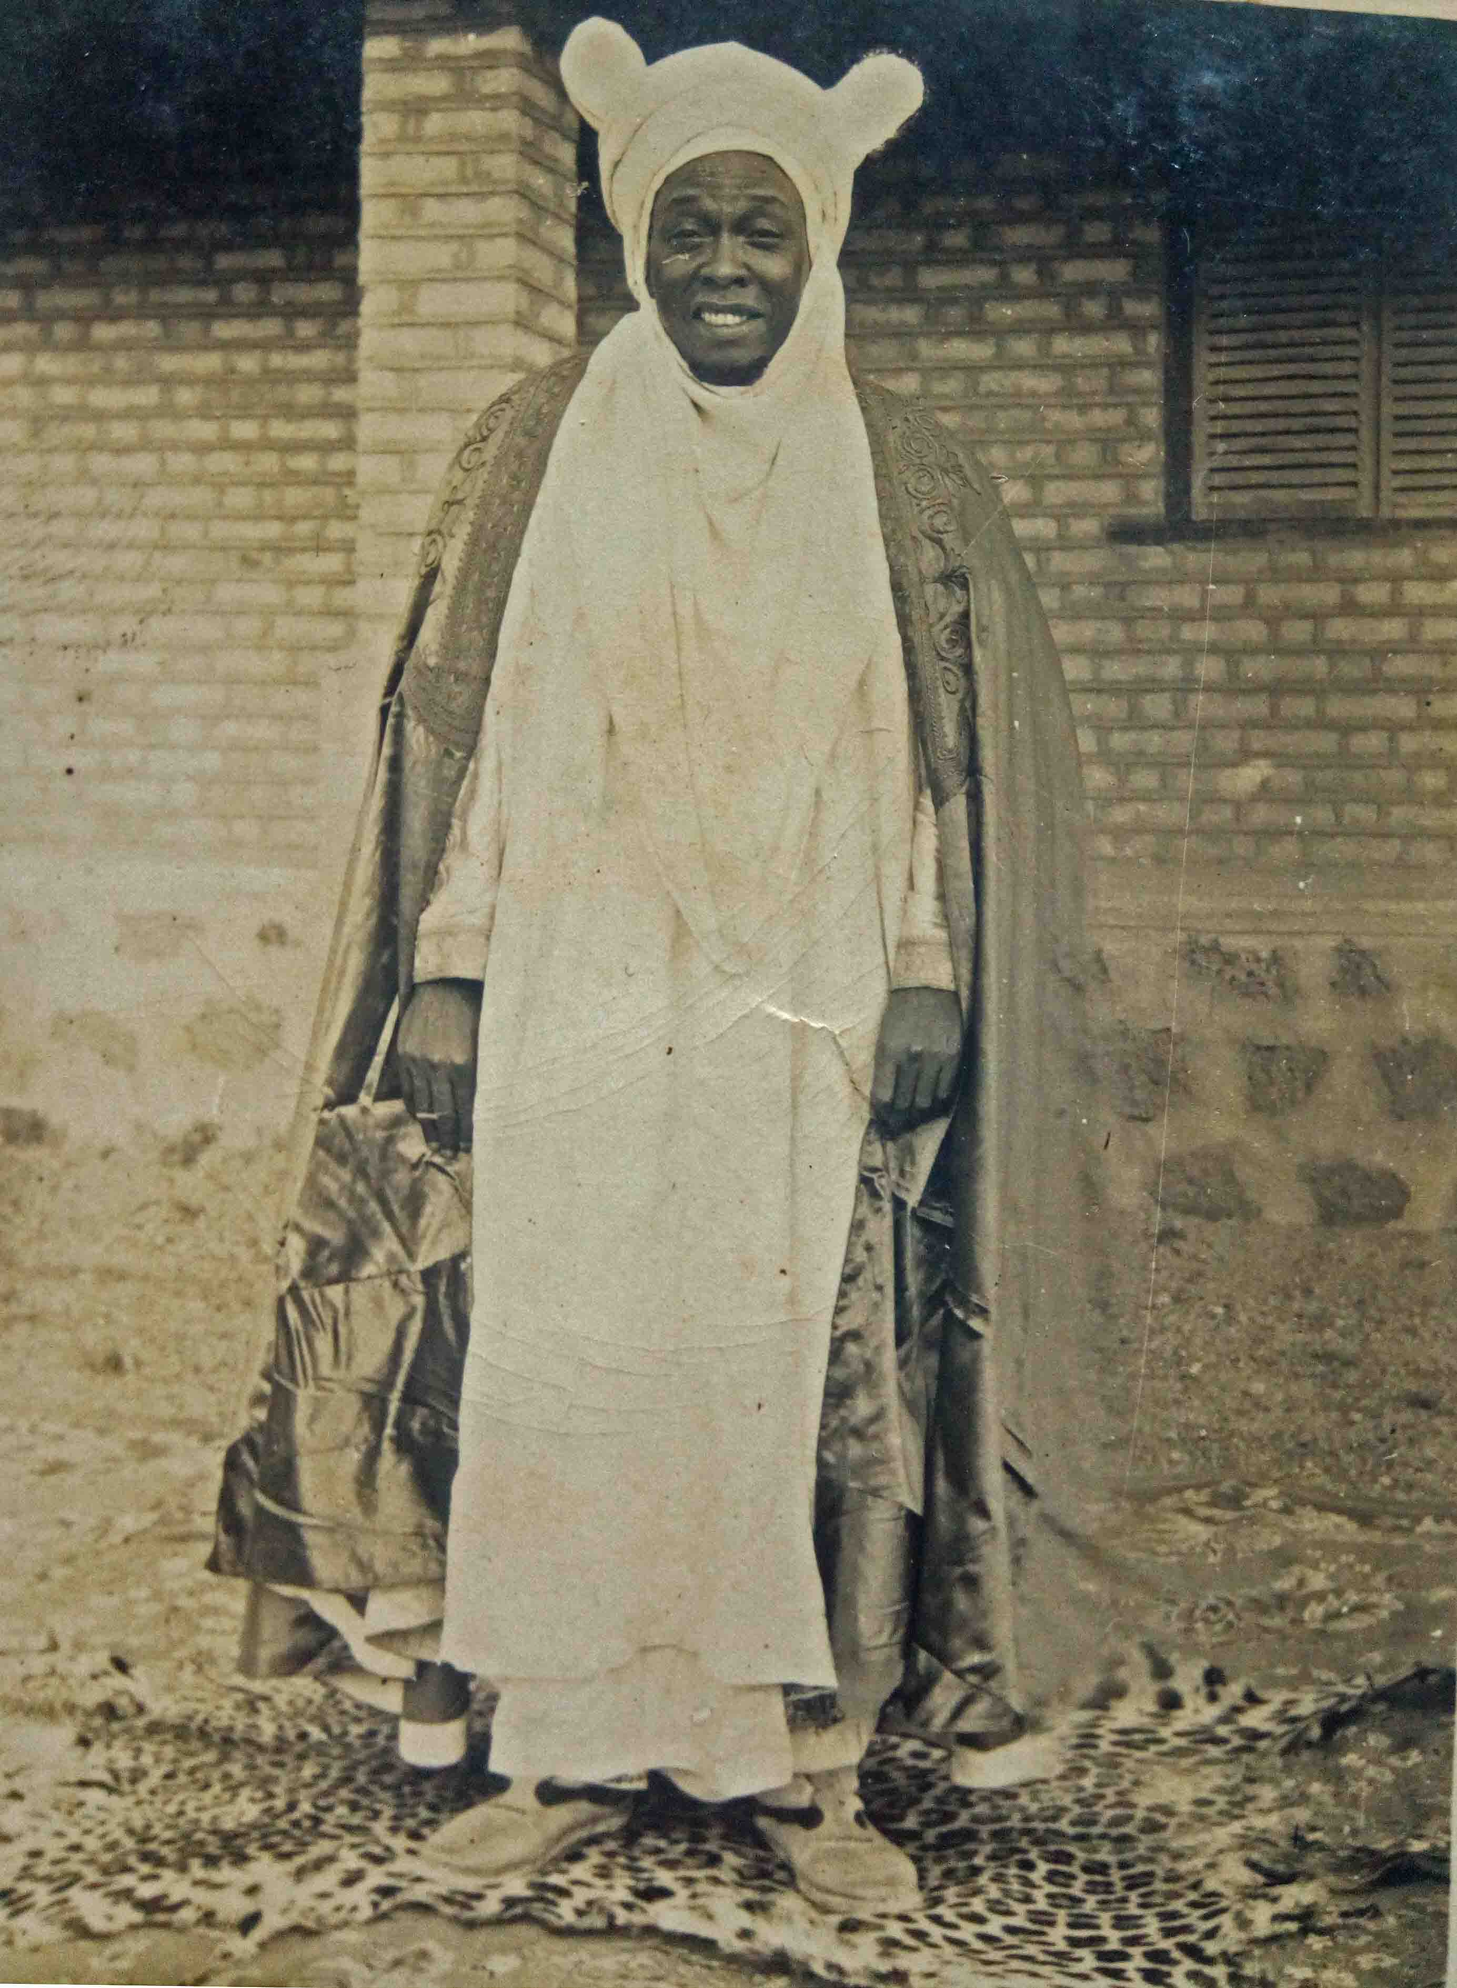
Photograph 2 Garbosa II, standing in front of the brick-built council hall, identified by Bobga Bobzom as one of the oldest buildings in the current palace, before it was plastered externally during the reign of Garbasa III (1982-1992). Possibly 1930s. Note the leopard skin, and the turban wound in a style similar to that he wore late in life (see Photograph 7).
The travels that Garbosa made after he became chief are described both in his second volume, The Family Trees, devoted explicitly to the chiefs of Donga, and in further additions made to his original History, before the two texts were issued as a single volume. A trip with some of his officials in 1935 by train from Makurdi to Enugu and Port Harcourt, and from there by sea on the MV Apapa to Lagos, had introduced him to various forms of power production, to the technique of welding and, to the device that most impressed him, wireless. His arduous trip to the British-administered Southern Cameroons Trust Territories in 1954 to visit the fondoms (chiefdoms) established there under Chamba leadership, which he recounts in detail, went some way to filling what he considered to be the gaps in his account of Chamba movements. The outcome of the 1961 United Nations referendum, which would unite the Northern Cameroons Trust Territory with a recently independent Nigeria, and its Southern Cameroons counterpart with Cameroon, lay in the future. The Chamba of Bamenda were for practical purposes almost fellow nationals in 1954.
These fellow Chamba received me with joy and astonishment at how I had determined to go to see them in person and not just send a message. At every chief’s residence when I arrived, elephant tusks were blown! I say to you, at that moment I came out in goose bumps […] (98)
In one place there were 3,000 or 4,000 or 4,500 people, and schoolchildren from 123 to 800. They pay more attention to dancing and celebrations than we Chamba of Benue Province do. The moment a horn is blown, or a drum is beaten, then they will run out, men and women, everyone, like the way the police or scouts do at the blow of a whistle. And once they start dancing and playing, they will not stop soon, they will go on for a long time before they finally come to a stop. (98)
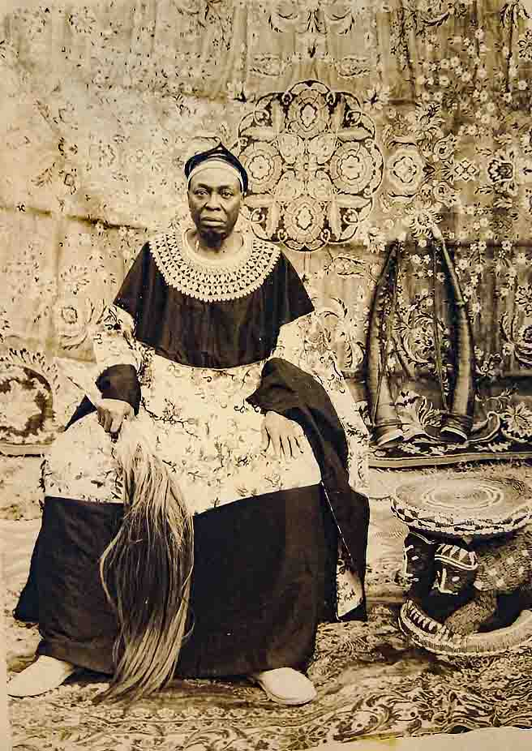
Photograph 3 Garbosa II in Bamenda cap and robe, now widely adopted as Chamba dress for special occasions in Nigeria, with the accoutrements of a Grassfield fon (hanging cloths and rugs underfoot, leather-covered oliphants, beaded stool, horsehair fly whisk) during his visit to the five Bali Chamba chiefdoms of the then Southern Cameroons Trust Territory in February 1954.
A recent highlight that had occurred just before Garbosa’s book was published, though one tinged with disappointment, was the visit of Queen of England and her husband the Duke of Edinburgh to Nigeria in early 1956, when on ‘2 February’, with ‘some of my people’, Garbosa attended the great meeting, or durbar, of all the peoples of the North in Kaduna. Being on horseback, he was unable to wear the long toro garment that hung down under the gown (98), which he does wear for the full-length portrait gracing the cover of his book, and he regrets that the Chamba were not among the peoples invited to show off their traditional performances (120).

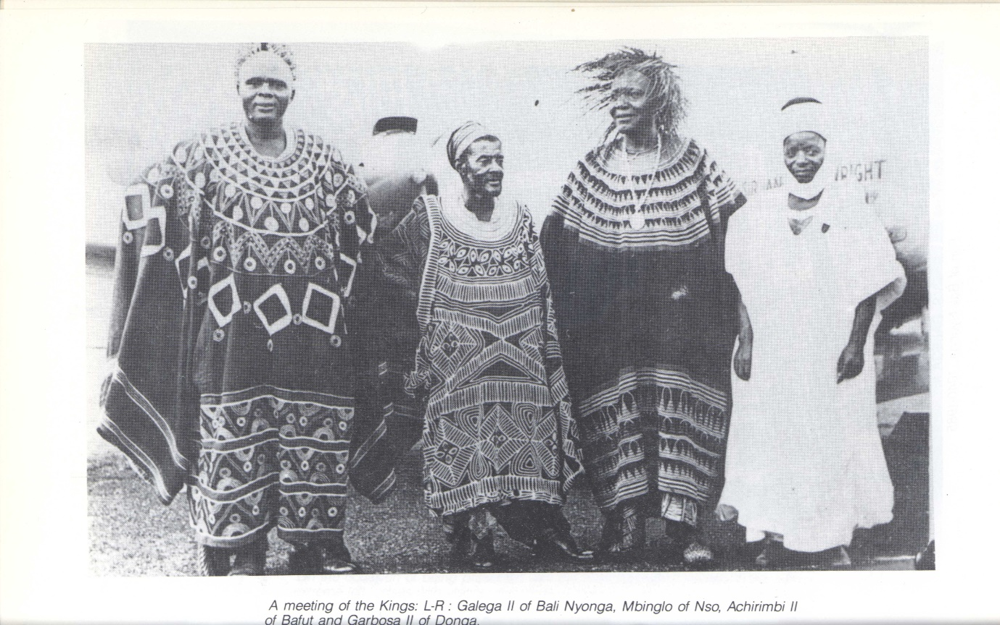
Photograph 4 That the Bamenda gown was not Garbosa II’s usual ceremonial costume at this time can be seen from another photograph in which he posed in Hausa-Fulani robes alongside the Fons of Bali Nyonga, Nso and Bafut. Published in Ndifontah B. Nyamndi 1988 The Bali Chamba of Cameroon: a political history (illustrations unpaginated). The occasion is not stated, although the text refers to Garbosa’s visit of 1954. It might alternatively derive from the 1956 Royal Durbar, which may explain the propeller aircraft visible, albeit indistinctly, in the background.
Through all these experiences, Garbosa developed a keen sense of the betwixt and between position of a chief under indirect rule, needing to face two ways at once in order to succeed.
In my chieftaincy I had to hold myself back because I could not make full use of all my knowledge. Little by little and very carefully I had to lead my people forward. I had knowledge of many things but was not able to articulate them fully, for who would have believed me? I had deepened my understanding of the things of this earth and of space through talking to Mr C.K. Meek, because every evening I was his companion and we talked constantly, and he got to like me. What I learned at school was about a third of what I knew, and the remaining two-thirds came from observing people around me.
In my chieftaincy two things occupied my mind, (a) I was careful to ensure that the Europeans did not think I was making too much of myself because of my knowledge (‘a little knowledge is a dangerous thing’), (b) I was careful lest my fellow black people should think I was being European. (153)
Many of the preoccupations of Garbosa’s texts are characteristic of his times, for instance, querying the precedence between colonial chiefs: had the Chamba not scattered, he asks rhetorically, surely their population would have merited a first-class chiefship, whereas Donga had only a third-class staff of chieftaincy (67, 148). Then there were the periodic worries about the claims of usurpers, familiar from the pre-colonial history he absorbed from his elders, their charlatan ranks swelled after the arrival of Europeans by such chancers as unscrupulous translators and clerks exploiting the misunderstandings of the more naïve colonial officials. The example of Takum, where the British had replaced the Chamba chief with one drawn from people local to the area, was salutary (see note 11) though not unique given a similar outcome in Ibi. To these were added concerns over the governance of Northern Nigeria and modern Nigeria and the part to be played by ‘traditional’ rights, particularly when these prerogatives were ethnic ascendancies created by relatively recent conquests. Such contests spilled over into arguments about the boundaries of administrative units and the precedence between the political entities of the pre-colonial period (a theme of relations between Fulani, Chamba and other ethnic groups, as well as between Chamba chiefdoms, notably Suntai and Donga). British justification of indirect rule in terms of historical precedents afforded the past a particular importance in these arguments, and the colonial ethos invited chiefs to borrow a rhetoric of progressive benevolence similar to that which the British used to naturalize their right to rule.
Although I have outlined all the good ways in which they [subject peoples] were governed, I don’t mean to imply that nothing bad ever happened to them, not at all, the Chamba enslaved them, sold some of them, but this was a time of deep ignorance, people did not know what was right, and this was true not only for the Chamba, everywhere in Nigeria it was like this. There were those who were defeated in battle, or those who fled to where nothing could happen to their villages (hills) without them knowing, and a person and his followers would have to retreat as far as they were pushed. This is the way things were until the light of British justice appeared, and the Chamba accepted it, and made great efforts to abide by what this new rule dictated.
The Chamba know of no other power that has ruled over these people that we have governed. And there is no one who can bear witness to, or demonstrate signs of, any walls that one could say show that others have lived there. Were it not for the Chamba who opened these people’s eyes, they would have been stuck in the darkness until the British came. If someone doubts this, then what did any rule do, that preceded the Chamba, to advance these people, or to unify them, or to prevent war? There is no evidence of this in history or in reliable stories, other than perhaps in imaginary fables.
There is no one who can say when the Chamba entered this land or that someone made war on them intending to take the land from them, or to rule over them; this is not attested to even in imaginary stories. Talk of the times of ignorance has gone and we have forgotten it all, we live in peace with everyone, and it is in this way that the country will move forward. (127)
In all honesty now we should be thanked, we received an education from the Sudan United Mission (SUM) and among our children and grandchildren there are those who have become senior secondary school teachers, or teachers at senior primary (SP) or junior primary (JP) schools, and some are working in a variety of Native Authorities. So, I often think there is no escaping the fact that the Mission deserves praise in this country of ours. (129)

Garbosa’s histories
The government anthropologist C.K. Meek, whose account of Donga and its history we have seen was not independent of Garbosa’s, characterized -
… the disorganized condition of tribal life in the Benue regions during the nineteenth century. The pagan tribes were broken up by the Fulani; Chamba fought Chamba; and the Fulani were in a constant state of feud with one another. (1931b I: 334)
Terms other than tribe and pagan would be used in academic texts today, but the portrayal of conflict and violence remains accurate. Meek continues,
The ancient sovereignty of the Jukun chiefs became so restricted that Donga, a town within a day’s journey of Wukari, recognized only the suzerainty of the Fulani of Kundi (though slaves were also regularly sent to the Fulani governor of Bauchi). (1931b I: 334)
The nature and extent of Jukun power before the nineteenth century, as well as the relations between Donga and various Fulani lamidates during that century, became entwined with twentieth-century politics thanks to British indirect rule grounding itself in historical justifications. The characteristic concerns of colonial assessment reports and anthropological enquiries are close to Garbosa’s own preoccupations with family histories, succession lists, territorial claims, relations of domination and subordination, and so on. Given a turbulent nineteenth century, precedents for indirect rule abounded in the Benue valley but also conflicted depending on whose account was heard. No cause was entirely forlorn, as Governor Palmer’s scheme to resurrect powers that he considered the Jukun to have lost in the eighteenth century demonstrated. Position at the outset under indirect rule may largely have been a matter of who held what when the colonial powers took over the use of force from commercial interests, but the de facto situation might still be challenged by earlier claims to power or indigeneity.
Garbosa narrates Chamba history as the actions and interactions of leaders. This is obvious from the title of his second volume, The Family Trees of the Chiefs of Donga, but it is almost as much the case for The History. The framework of The Family Trees is provided straightforwardly by accounts of the sequential reigns and achievements of the chiefs who led the Chamba from their homelands into the plains south of the Benue and went on to rule Donga. Up to the reign of Nubumga Donzomga and his successor, The Family Trees covers much of the same ground as The History; its main originality is to be found in the lives of the later chiefs, including that of the author himself. Garbosa’s first volume, The History, is the longer and more complex of the two because in it he sets himself the task of writing a history of all the Chamba, and not simply the branch which went on to rule Donga. Frequently he is the only published source for this detailed history, which is written from his position as Gara Donga. Hence, readers have to weigh his aspiration to be exhaustive against his particular interests, conscious that we rarely know how the same events seemed to parties other than Donga involved in them.
In addition to his genuine historical curiosity, Garbosa is committed to including all Chamba under the widest reach of that ethnic identity because he feels that the importance of his people has been underestimated on account of their dispersion. As already noted, he believed that if they were all together, they would surely have merited a first-class chief. From what he knew of them, Garbosa distinguished five main branches of Chamba: of these, the first and fifth are respectively those who remained in their homeland, and those who left that land eastwards into Cameroon. In the event, he has little to say about either of these two branches, despite the first group, those who did not emigrate, being the most populous. His trip together with Meek does not appear to have taken him as far south as ‘Chambaland’; he cites no places visited there. And Garbosa appears to be misinformed about the fifth branch of the Chamba who he supposes to have headed east; Chamba settlements in northern Cameroon in fact lie within what, at the start of the nineteenth century, had been Chambaland. So, the first and fifth groups are the same, and anyway neither features in his account. Garbosa’s narrative is entirely concerned with the emigrant branches he enumerates as, 2) consisting of two streams of migrants into the Benue Valley, 3) a stream of migrants who headed south before also turning west into the Benue Valley, 4) the migrants who headed south towards the Bamenda Grassfields of Cameroon and eventually founded the five Bali Chamba chiefdoms there. Garbosa visited the Bali Chamba and was well-received by them, but his initiative made history rather than adding to what is known of the histories of the five fondoms (which were to be researched intensively soon after his visit by E.M. Chilver and Phyllis Kaberry, see Kaberry and Chilver 1961, Chilver 1964, Chilver and Kaberry 1968). Hence, although an extensive sense of Chambaness informs Garbosa’s History, in the event his intensive research was restricted to those emigrants he listed under 2) and 3), which is to say those who settled in the hills and plains south of the River Benue. Garbosa’s sketch map of the places relevant to their movements, below, may also be found in both the Hausa original of his book and its English translation (71).
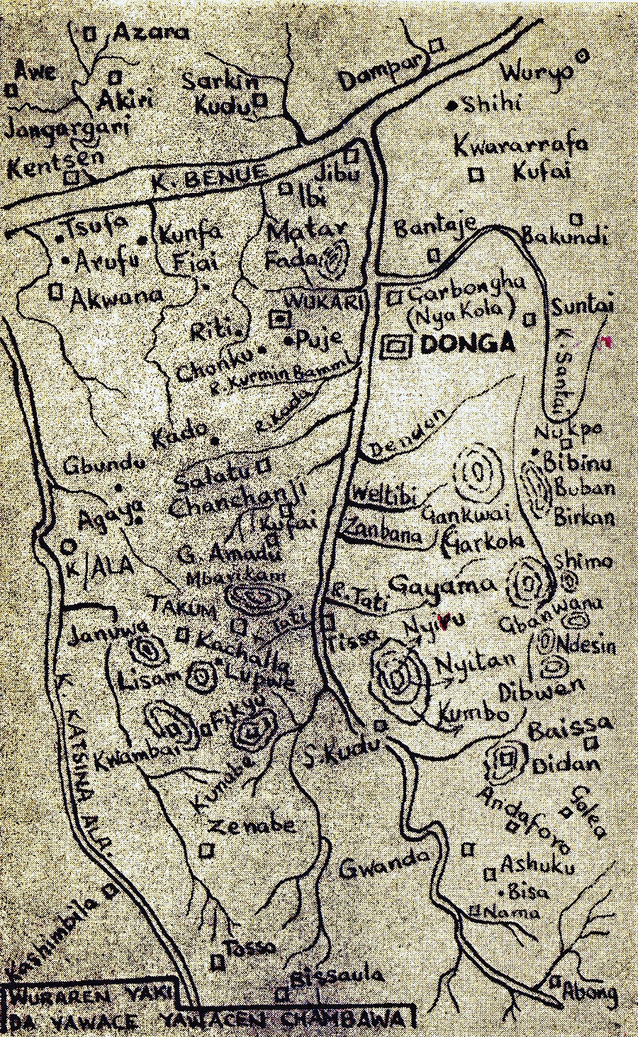
Sketch map from Garbosa’s History

To appreciate the distances and dimensions involved, readers can compare his broad representation with an early British map of a larger region.
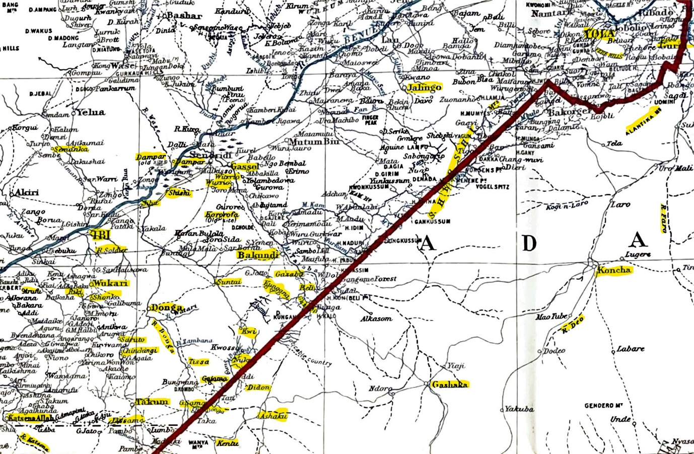
Map The Benue Valley between Yola and Ibi: places and features mentioned in Garbosa’s text are highlighted, Ordnance Survey 1913. The red line is the Anglo-German border between Nigeria and Kamerun
Understandably, Garbosa’s most particular interest is in the forebears whose movements culminated in the foundation of his chiefdom of Donga. Indeed, the main protagonist of this narrative is his own grandfather, Nubumga Donzomga, who gave the place its name: Donga being a contraction of one of his given names, rather than his regnal, name. The foundation of Donga provides this meatiest thread of Garbosa’s narrative with its pivot, or its before and after; so, the most straightforward approach to the complex structure of The History is initially to tease out this sequence; most of the other narrative threads relate to it in one way or another.
The first twenty-odd pages of the translation of The History (68-86) concern the events which took place between leaving Dindin (Chambaland) and the foundation of Donga, followed by various listings of names (of the chiefs of Donga and Suntai, the council members, the grandchildren of the chief who led the migrants from Chambaland …). Garbosa then shifts his focus to some other places at similar length, before resuming the history of Donga under Nubumga Donzomga and his successor (106-108). Our summaries of these two sections of The History have been supplemented by the later accounts in The Family Trees where they clarify the events narrated.
Nubumga Donzomga, the founder but officially the second chief of Donga, took the chiefly title Garbasa and was succeeded by three of his sons and then by a grandson whose four reigns, Garbosa calculates, occupied the forty-six years before his own accession in 1931. Were this dating of Garbasa’s death to 1885 correct (we doubt it is) then Garbosa’s older informants, those born around the middle of the previous century, would have known Garbasa as chief in their adulthood, and been aware as children of his predecessor, Garkiye, who died at a great age, we are told, just three years after the move to Donga, which we argue below took place around about 1860. The challenge to Garbosa as a historian is to account for what happened between leaving Chambaland and founding Donga, and to explain the relations between Donga and the numerous other settlements in the Benue Valley that the Chamba occupied for short periods or in permanence.
Nubumga Donzomga Garbasa was the first in the ‘family tree’ of the chiefs of Donga to have been born after the migration from Dindin, the place name Garbosa and Meek give to the Chamba homeland, which was the birthplace of the men said to have been his father, Doo Shimbura, regnal name Garkiye, and his grandfather, Loya Garbosa. Consistent with this tradition, the mothers of both Garkiye and Garbasa are recalled as belonging to the Pyeri, presented by Garbosa as a patriclan of Chamba, although in Chambaland a variant of the same term is applied by speakers of Chamba Leko to their southern neighbours, the Pere, who also use it of themselves (in earlier literature they are called Koutine, which is how they were known to the Fulani). In keeping with this account, Loya Garbosa and Garkiye could plausibly have married Pyeri (or Pere) wives before leaving Dindin, and the ethnic identity of Pere subsequently came to be treated as a component patriclan of Chamba in the Benue Valley. Wider ethnic or local identities commonly became patriclan names within the multi-ethnic, Chamba-led confederacies (as they have also in Chambaland). While Chamba and Pere were allies from the inception of their migrations, the mothers of the chiefs who reigned after Garbasa all came from peoples encountered after the movement into the Benue plains, a circumstantial detail that corroborates Garbosa’s overall account and goes some way to explain why the ‘mother tongue’ of the raiders ceased to be Chamba within a couple of generations. The leadership of the alliances, so it appears, took their wives from the people they incorporated en route.
The birthplace of Nubumga Donzomga, the future Garbasa, was the second of the camps established after the Chamba left their homelands; Garbosa calls it Gildu in his text. The first camp had been at Tipchen, set up under Loya Garbosa, the chief who, in Garbosa’s account, led the migrants from Chambaland. He was still leader at the second camp but on departing from there either died in crossing the River Gazabu, according to the account accepted in Donga, or was killed by a rival, according to a version of history recorded in Takum. The movement up to this point had taken the Chamba and their allies southwards down the valley of the Rivers Faro and Deo, then westward, skirting to the south of the Shebshi Mountains, which were largely inhabited by Chamba Daka, and then out into the southern plains of the middle Benue.
What happened next remained crucial to contemporary relations in Garbosa’s time and was also disputed. In terms of Garbosa’s account of the chiefly Sama patriclan, the leadership should have been inherited by Shimbura, the son of the late leader (and the future Garkiye), but Shimbura was preoccupied with war and allowed the older Nya Pyemishena, of the Kola patriclan, to succeed. Nya took the regnal title Garkola and established the then substantial settlement that bore his name, also known as Gankwai, the third camp since leaving Chambaland. Sections of the confederacy occupied neighbouring hills after subduing speakers of Jukunoid languages, suggesting at that moment they may have lacked the force needed to establish themselves in the plains. Garkola is presented by Garbosa as the most significant centre of Chamba dispersion into the Benue Valley, and his narrative returns to it, as well as to the earlier camps, to pick up the histories of the groups other than that which went on to found Donga. We look at some of these movements in slightly more detail later, but for now we may summarize that: the Chamba who left their homeland of Dindin did not do so in a single movement; some split off from the first encampment at Tipchen; further splits occurred at the second camp, Gildu; and yet more at the third, Garkola or Gankwai. The subsequent history of Chamba migrations is complicated, both for Garbosa and for his later readers, by the sheer frequency of splits, defections, conflicts, and alliances of convenience between sections during the nineteenth century. We shall not attempt to follow all of them here but interested readers may find them in the full text.
The distribution of Chamba migrants and the relations between by the end of the nineteenth century provide ample evidence for the overall shape of events, but the continuing significance of who prevailed, where and when, and whether they did so legitimately, means the details remain open to dispute. The various Chamba-led raiding confederacies marauding in the first decades of the nineteenth century provided a vanguard behind which the Fulani were to consolidate their authority as that century wore on. Initially, the Fulani of Adamawa had been both weak in numbers and themselves divided on clan lines; they needed alliances with the peoples of the river systems of the upper Benue and of the Faro and Deo which flowed into it, notably the Bata, Verre, Chamba and Pere. At this remove in time, we do not know how far these understandings were formalized, or whether the raiders set out on their own account or with the authority of the Fulani. However, the momentum of the Fulani ascendancy followed the valley of the Faro-Deo river-system to the east of the Alantika Mountains: Gurin (the early capital of the Emirate) was established among the Verre (farmers and industrious metalworkers), and two lamidates were implanted at Tchamba, among the Chamba Leko, and Koncha, among the Pere, along with a number of smaller settlements. With the exception of the Chamba associated with the leader Damashi, who Garbosa cannot fit easily into his narrative, all the Chamba migrants set off towards the south, as if away from the new Fulani lamidates. Each of the groups is recalled by the name of its initial leader: Loya Garbosa for the first group to turn west (including those whose descendants founded Donga), Gyando of the Chamba Dakka (whose descendants founded Takum) and Mudi of the Pyeri who both continued further to the south before turning westward into the Benue Valley, and the Ba’ni under Gawolbe who did not make the westward turn but pursued a course to the Bamenda Grassfields (where they set up the five Bali Chamba fondoms). Initially, these groups were able to leave the orbit of the emergent Fulani Emirate of Adamawa, but once in the Benue plains, and as the first half of the nineteenth century wore on, Garbosa reports how the different factions competed to ally themselves with the Fulani powers on the rise there, and to be granted flags, in theory to prosecute jihad, but in practice to raid as privateers. This was true not just of Donga and Takum, but it seems also to have been the case for the Bali of Bamenda, now in Cameroon, whose move south outstripped the Fulani advance but who nonetheless had a flag as their war standard, its name derived from the Fulfulde tutuwal (Fardon 2006: 55 fn27), which raises the possibility that the practice predated the Chamba Leko diaspora.
Garbosa tells us that after Garkola became chief at Gankwai he appointed Shimbura to the title of Tigye, a custodian of the drums. Despite this, tensions between the two escalated, and Shimbura moved out, accidentally leaving his, by then apparently adult, son Nubumga Donzomga behind, who was rescued by a titleholder called Gbaningha Kpanghati and reunited with his father, who responded by sending two slaves to Garkola. The party headed west across the plain towards what is now Takum, fighting the Kutep to establish the walled settlement of Jenuwa, where Shimbura himself became a chief with the regnal title Garkiye. At this, one of his chiefmakers, Gban Kuna (also known as Gardanpua), defected together with his people to join the Chamba ‘Dakka’ of Kumboshi who were also fighting in the area. The sense of the ethnic term ‘Dakka’ or Daka varies with context in Chambaland, but generally it would refer to western Chamba, who were also speakers of the Chamba Daka rather than Chamba Leko language. The entry of this group further south into the Benue Valley than that of Loya Garbosa’s, so Garbosa’s history tells us, occurred after Gyando (presumably the Gando of the Takum account, see note 9), who took them from Dindin together with their Pyeri (or Pere) allies led by Mudi, had been succeeded by his son Komboshi.
The conflict with Komboshi caused Garkiye to leave Jenuwa, from where he headed north, camping first in Arufu, where he replenished the numbers of his followers, then, short of food, to Ganako, close to contemporary Ibi, by which time ‘Garkiye I was quite old and all matters of making war were in the hands of his son, Nubumga Donzomga’ (73). Here, Nubumga Donzomga decided to seek a flag which, he learned from traders, were being given out by the Shehu in Sokoto, so that, as Garbosa puts it without mention of jihad, ‘all those who received a flag would flourish and however small a town they were from, it would soon become a city’ (74). Nubumga Donzomga left Garkiye and crossed over the River Benue but had to turn back on hearing that the chief of Jibu intended to attack Ganako. Having seen off the Jibu, Nubumga Donzomga again crossed the River Benue, this time settling Garkiye there, and set off to request a flag from the Emir of Bauchi, whose orbit he had entered. From around the time of these events, we have the first written reports of the Chamba settlements that are contemporary with the events they record. C.K. Meek, as we have seen for a short time the young Malam Sambo’s employer, made the connection between this Ganako and the places visited by the Macgregor Laird expedition, sponsored by the British merchant trader of that name, which ascended the Niger and Benue in 1854. Precisely how the date 1854 correlates with Nubumga Donzomga’s two missions to the Fulani powers is uncertain, but the events occurred around the same time.
William Balfour Baikie, who became its leader, the missionary Rev. Samuel Crowder, and Thomas Joseph Hutchinson, the engineer, all wrote accounts of the Macgregor Laird expedition which we quote verbatim since the original texts may be difficult for Nigerian readers to consult (Kingdon 2019: 15-18 provides a succinct account of the background). According to Baikie, Gándiko, presumably Garbosa’s Ganako, which they visited first, had been founded following an attempt by a ‘Púlo [Fulani] force, chiefly composed of slaves, to attack Wúkari [the Jukun capital], in which they failed’ (1856/1966: 125). The district was named ‘Zhíbu’ (i.e. Jibu) and the two nearby towns were called ‘Gankéra’ and ‘I’bi’ (1856: 126).
Crowther’s account adds more local detail,
… we anchored off the villages of Gandiko, whose chief was Ama, and Gankera, whose chief was Garike. Before the ship came to an anchor, intelligence had reached the chiefs of the villages, and all hands were up in arms. Their weapons were bows and poisoned arrows, and long spears, and some men carried three or four of the latter poisoned also. (1855: 78)
[The following day] Ama the chief was interrupted; Garike the chief of Gankera was outside, and he ought to have been invited in, which Ama did not feel inclined to do. [After some negotiations] he went out and invited Sariki Garike in. This man looks older than Ama, and neither of them appeared to understand, or at least they would not speak Haussa, the Filani language being their medium of communication, as well as the Djuku [Jukun], which is the language of Kororofa. [The party] visited Gankera, the next village, much larger than Gandiko, where we saw some Arabian horses in very good condition, kept purposely for catching slaves. (1855: 81-83)
Baikie similarly describes how, while visiting the king of Gándiko, the ‘king of Gankéra was announced’, so the party walked the ten minutes to Gankéra, discovering it to be the larger and ‘better laid out’ of the two, its huts surrounded by gardens and a small market (1856/1966: 127).
Hearing that there were horses we asked to see them, and were accordingly shown several fine Arabs, nicely groomed and cared for, and in fine condition. In each stabler hung oval-shaped shields made of elephants’ hides, large enough to protect both rider and steed. […] Most of the inhabitants were clad in native-made clothes, but some appeared in garments made of goat-skins, while a few [probably describing women] wore still more scanty coverings of green leaves. During our walk we again met the old chief, Garíke, who made me a present of a mat. Annual excursions for the purpose of collecting slaves are made from these towns chiefly against the Mítshis [Tiv]. (1856/1966: 127-28)
Hutchinson’s attention was drawn particularly, and with condescending irony, to the appearance of the inhabitants of both places: the women with elaborate hair crests decorated with metal ornaments, as were their nostrils and stretched, open earlobes; some of the men with similar ear ornaments wore ragged Hausa tunics (1855: 105-7). But he is admiring of,
… an immense tract of land here devoted to agricultural purposes. Between Gandiko and Gankera, a neighbouring town, over which Amee’s brother Gorakee presides – not a single ground is uncultivated for a walk of nearly a mile in length. The latter town is larger than Gandiko, and is a paragon of neatness in all its streets – its ovoid and quadrangular spaces – in the centre of which many trees are nurtured, and spaces paled in for mats to be laid upon. French beans are growing against the palisading outside the houses, as though they were under the fostering hand of the head gardener at the Jardin des Plantes in Paris. Three of the finest Arab horses I have ever seen were in stables at Gankera; and in one of the stables was a large shield to protect horse and rider from the arrows of an enemy. (1855: 107-8)
Meek supplements these accounts with a contemporary recollection from the Chamba side, not mentioned by Garbosa (Meek 1931b I: 330), that is at variance with both Baikie and Crowder’s first-hand testimonies but serves to foreshadow the transition between Garkiye and Nubumga Donzomga.
It was related that […] a European expedition came up the river, and that Gakie [Garkiye] visited the ship and was offered numerous gifts, which he refused, saying, ‘You offer these gifts because you wish the land, but the land is God’s, not mine.’ Gakie’s son Nubunga [Nubumga Donzomga], however, went secretly to the Europeans and said that his father was an old man and spoke after the fashion of old men. And so Nubunga obtained the presents for himself!
It seems at this point that the Chamba-led alliance, already speaking Jukun as well as Fulfulde, wished to loosen the grip that Jibu had on them by allying with Bauchi (see also Hamman 2007: 136-39). Writing from the Bauchi perspective, Hamman dates Nubumga Donzomga’s alliance with Bauchi to around 1852-53, which would be before the visit of the Pleiad (Hamman 2007: 136 fn18). Returning from his second journey in search of a flag, during which he and his men had assisted Ibrahim, the Emir of Bauchi, valiantly in battle, Garbosa tells us that Nubumga Donzomga brought with him not only a flag, but also an execution sword, horses and thirty Jahun (Meek’s Jafunawa) warriors under one Barde Karijo. They were subsequently joined by more Jahun warriors defecting from Jibu, one of whom is said by Garbosa to have killed Lamido Kuso, the chief of Jibu. Meek notes variant accounts in which the chief of Jibu called Boderi was killed and reckons the attempt to defeat Jibu unsuccessful (1931b I: 332). Leaving aside the details, it would appear that Nubumga Donzomga and Garkiye, threatened by Jibu, successfully threw in their lot with Bauchi. Quite when, in the sequence of events, the Pleiad’s visit of 1854 occurred is uncertain. The presence of fine Arab horses might be taken to indicate that the Bauchi alliance was, as Hamman also suggests, made just before 1854, by which time the attack on Jibu had not yet occurred. But this dating leaves us with a discrepancy, because Garbosa reports that the Chamba settlements on the south bank of the River Benue were shifted north of the river by the time of the alliance with Bauchi. In whichever case, and perhaps as a result of their reinforcement by the alliance with Bauchi, Garkiye and Nubumga Donzomga next turned south to return in the direction of Garkola, thereby closing a clockwise movement around the valley of the middle Benue south of the river. Despite Garkiye’s promptings, Nubumga Donzomga declined to enter Gargbanyi’s town, and Donga was founded on its present site by the displacement of Suntai only after a subsequent conflict over food shortages. Three years later, we are told by Garbosa, Garkiye died in old age plausibly at some time, give or take, around 1860.
By this point, Garbosa’s narrative of Chamba dispersal has reversed to become one of, at least partial, reunification, which included the settling of old scores, as some of the components originating from the earlier war camps became subject to Donga. The most notable, and contentious, addition was Suntai which the British colonial administration was to include under Donga in 1913. This had stemmed after another succession dispute, following Garkola’s death at Gankwai, which led to the secession of the group that went on to found Suntai under the leadership of Nyonzuma (who took the regnal title Gargbanyi). Nubumga Donzomga’s forces settled nearby but running out of food took to looting the Suntai farms. Gargbanyi rallied his allies leading to armed confrontation between, on the one hand, his Chamba, supported by the Jukun as well as (Garkiye and Nubumga Donzomga’s former adversary) the Fulani of Jibu, and, on the other, Nubumga Donzomga’s Chamba alongside the Fulani of Kundi (76-77). Gargbanyi’s defeated forces fled to Jibu, staying there for three years, before moving to Wurio where, after a further seven years, Gargbanyi died. His successor moved to Suntai which Garbosa reckons to have been founded in its current site by 1873; an event for which Meek proposes the earlier date of 1865 (1931b I: 333). This range of dates, taken together with the record from the Pleiad, suggests in rounded terms that Donga had been founded about 1860 and had grown into a walled town a mile or so south of the site that Gargbanyi soon vacated, and that Suntai returned to its current location about a decade later. On the death of Garkiye shortly after the town was established, Nubumga Donzomga took the regnal name of Garbasa.
Garbosa suspends his narrative of Donga at this point to spend the next twenty pages introducing us to the other Chamba-led groups that left Dindin. We shall return to some of this, but for clarity now continue his account of the expansion of Donga, as outlined in both the History (from 107) and Family Trees.
Donga was the first place in the region, according to Garbosa, to adopt the architecture of the north. The observances to protect its gates are also presented as the initiative of northern, Muslim scholars. The town walls would be expanded three times as people flocked there in search of its relative security, notably from the war of Hamidu, fourth Emir of Muri (who reigned 1861-69 according to Garbosa, the same dates provided by Fremantle 1922: 18). Fighting hardly relented in the next decade. Garbosa claims Garbasa defeated Aliyu chief of Bantaje, an offshoot of Jibu and ally of Suntai, even bringing up (or perhaps holding hostage) his children (107). A brother, Gbunyela, was sent to Nyivu to control the Kentu living there, but he was taken as a hostage to Gassol (founded from the Emirate of Muri) and had to be ransomed; Garbasa then moved some of the Kentu to be under his control to the early camp which had been called Garkola, after its leader, or Gangkwai (109). By doing so, he completed his retribution on the place he had left at the outset of his transit around the plains. At this point, Garbosa writes that having found some respite from his administrative duties, he would tell us, his readers, of one more of Garbasa’s wars, in alliance with Wukari to attack his longstanding enemy Jibu. They had stopped en route at Jibu’s ally Nyakola to provision themselves by taking the harvest, when the two chiefs were taken unawares by forces from Jibu aided by Bayaro, the son of the Sultan of Sokoto, who was raiding the area. The Jukun chief, Ashumanu I, was killed, but Garbasa and his sons escaped by the skin of their teeth. Bayaro was recalled to Sokoto by his father in 1871 according to Fremantle (1922: 38). The sufferings of the town of Donga were not done, since Garbosa reports a severe outbreak of smallpox after this conflict, but the place flourished economically in ways enumerated in The Family Trees. Indeed, Garbasa accumulated great wealth, ‘[d]uring his time great gowns and burnouses, along with horse apparel, were brought to him from Hausa and Nupe country. He amassed much wealth and reigned for all of forty years’ (134). ‘From among the customs of the Hausa, Garbasa adopted such things as drummers. He started the Friday drumming and the use of oboes and horns’ (134).
If, as Garbosa tells us, Garkiye died three years after Donga was founded, and given Garbasa’s successor Gargbanyi signed a treaty as chief in 1885, then Garbasa could not have reigned for forty years after Garkiye. It seems we have two alternatives (or a bit of both): two identical reigns of exactly forty years sounds too coincidental, so we might interpret ‘forty’ to mean ‘long’ given a counting system in units of twenty (see note 8); alternatively, or probably additionally, we could point to suggestions in the text and in contemporary reports for Garkiye and Garbasa holding chiefships simultaneously for a considerable part of the period (see note 12). Whatever the case, Nubumga Donzomga Garbasa’s reign in Donga established the new chiefdom securely in what we have seen was a perilous environment. By Garbasa’s death, Garbosa estimates the population of Donga may have approached 10,000, and in addition to a palace built of bricks, Garbasa had needed to build a storeroom to accommodate the great extent of his wealth.
Garbasa’s son and successor, Bileya Gargbanyi, had been born in the camp at Jenuwa, near present-day Takum. The Niger Company became increasingly influential in local affairs during his reign, opening a station at Donga in 1885 (according to Garbosa the year of his accession, although Fremantle’s earlier account (1922: 41) suggests this had occurred in 1877, see above). Garbosa characterizes him as hot-tempered and wealth-seeking. The means of warfare were changing, and Gargbanyi emulated the Niger Company’s Constabulary in a similar fashion to the Chamba conquerors in Bali Nyonga under early German colonial rule, forming a small armed infantry (see Fardon 2006: 56-69).
Gargbanyi collected guns and gave positions to those who knew how to use them, he had jackets and short trousers made for them and he placed a great deal of trust in them. He was never parted from his shotgun, day or night. The shotgun was always there under his chair. (137)
Gargbanyi came to the aid of Donga’s old adversary, Takum, to oppose Kachalla, a disappointed successor to the Takum throne (111-12). Kachalla would not finally be defeated finally before the involvement of the Niger Company during the reign of Gargbanyi’s successor, Sonyonga Garbosa I. As his reign wore on, Gargbanyi came to be ‘corrupted’ by an ‘evil courtier’, a Jiba man called Nya Yeba (81, 112, 136-37, 139,156-59) who set him against his brother and heir apparent, Sonyonga (significantly Garbosa’s own father), and persecuted any who stood in his way under the pretext of an anti-witch hunt. People’s fear of Gargbanyi prevented them from asking him to stop Nya Yeba’s activities until, sick and close to death, Gargbanyi saw Nya Yeba dressed as if he was his successor, at which he had Yerima (Prince; also spelt Yerma, or Yarima, by Garbosa) Sonyonga kill both him and his mother, so that Nya Yeba’s descendants were reduced to a mere two grandchildren. Garbosa concludes The Family Trees, and hence his published volume, with this cautionary tale. The only episode entirely out of sequence in that otherwise chronologically organized narrative; a placement that does not feel fortuitous.
Suntai would feature in a violent episode in 1895 when it was reduced by the Royal Niger Company following the death of one of its officers there (Fremantle 1922: 9). The Company had been supporting the authority of Bakundi against which Suntai rebelled when the officer in charge recklessly, according to reports, lost his own life, as well as those of two of his men, six more of whom were wounded when trying to mount the town walls under fire. The town fell in an ensuing action in 1899, although its ruler (Porba, in Niger Company records, or Poba with the regnal title Garjila I third chief of Suntai, in Garbosa) survived, admired for his courage (Fremantle 1922: 10).
Gargbanyi’s reign lasted only seven years according to Garbosa, when he was succeeded by his brother, and the author’s father, Sonyonga or Garbosa I (reigned, 1892-1911), the first chief to be born in Donga, and the first to have been titled Yerima (successor and prince), a Hausa-Fulani practice adopted it is said under the influence of Bakundi. Before he was appointed Yerima, Sonyonga had been the immediate neighbour of Audu, the first imam of Donga, who instructed him in Islam.
This is why he liked Fulani things and going to Fulani houses didn’t bother him. We Chamba were of the view that his efforts were greater than some of the Islamic scholars. He even decided to send some of his sons to school in Kano with Malam Ibrahim, but never had the opportunity to do so before he died. (138)
Although Garbosa I was a Muslim, the SUM was allowed to open a station in 1907, and missionaries settled in 1911, the first convert being baptised in Donga that same year. Garbosa I had, according to his son, around 150 wives and more than a hundred children (although he lists considerably fewer by name). It was in Garbosa I’s reign, that Kachalla, the non-succeeding member of the Takum ruling family discussed above, set up a camp among the Tiv from where he attacked the trade routes around Ibi and Donga; he was finally defeated after several attempts and killed following an assault by the Royal Niger Company in 1896 (Fremantle 1922: 8-9, 11-13).
Wanga or Garkiye II (1911-21) next became Gara, the third of Nubumga Donzomga’s sons to succeed him. Once more the succession was problematic since Angulu, the interpreter angled for the post having seen that,
… the Europeans had given Amadu Likam the chieftaincy of Takum, and to Umaru dan Sidi the chieftaincy of Ibi, the Europeans were clearly not interested in matters of birth and lineage! Things were in such a state that anyone could make it to become chief. (146)
Angulu’s plan was thwarted, but Garkiye II’s reign was not a happy one. In an Assessment Report of 1921, R.F.P. Orme refers to the death on 30 May of a late District Head of ‘an easy disposition’ and urges the ADO, Mr Whiteley (reported by Garbosa to have been given the, apparently affectionate, nickname of ‘pregnant woman’ by Chamba), to encourage his successor ‘to show a more energetic spirit’ (EAP 535/2/4/1/4 para 51). According again to Garbosa, whose account of the same chief’s misfortunes during the First World War we quoted earlier,
His time was most regrettable, everything relating to administration deteriorated, there was a shortage of people in the town, and many houses became neglected. The hearts of the Sama people were downcast at how everything to do with the nobility had gone bad and was continuing to go backwards.
During Garkiye II’s time the first meeting at Ibi was held. He was the first chief of the Chamba to be given a staff of office by the Governor, a Third Class Chief. At every meeting the messengers and interpreters caused him trouble and pushed him back. While their star shone bright, they had their opportunity to sow their evil as they wished. This kind of thing happened everywhere across the Northern Region at that time. (148)
Garkiye II’s successor, Nyaga Garbasa II (1921-31), although the son of Gargbanyi, had been brought up after his death by his father’s brother, Garbosa I (our author’s father), and in many ways resembled him in his aptitudes for hunting and horsemanship. Although Garbosa does not mention this specifically, according to the colonial officer R.F.P. Orme, Nyaga had received some education in Hausa literacy from the SUM (EAP 535/2/4/1/4 p.27), or as Garbosa put it, ‘He knew how to read a little of roman script, and write in it, and do a little mathematics’,
[Garbasa II] was not popular among the interpreters and the messengers of the Europeans, particularly those like Siddi (interpreter) and Mamman Nafada (messenger), exactly as it was in the time of Garkiye II, and often he would be involved in fights with them because of their trickery. We had no respite from this kind of thing until the time of Pregnant Woman (Mr M. R. Whiteley, may Allah heap value upon him). He it was who opened up the process of government properly and dimmed the light of these people. Work went on as straight as a die, and progress was made. (150)
With the death of Garbasa II in 1931, we come full circle to the accession of Garbosa II, the authority on the history and customs of the Donga Chamba, with whose biography we began this essay. Garbosa’s missionary education and colonial experience had made him a progressive in his own eyes, and an enlightened ruler in the view of British officials, a small circle he knew well, not just the local colonial administration but educators like Rupert East and the anthropologist, C.K. Meek. How and why Garbosa wrote his texts is clearly related to this formation. Although his works seem primarily to be addressed to Chamba readers, they were written in Hausa. By Garbosa’s time it is likely that Chamba Leko was hardly spoken in Donga where a dialect of Jukun was the everyday language. Hausa, the language of colonial and most missionary instruction, could be read by educated speakers of Chamba Daka and Chamba Leko in Nigeria, neither of which, mutually incomprehensible, languages had an agreed orthography at that time. The readership excluded by this choice included the small numbers of Chamba Leko in the north of the French Cameroun Trusteeship, as well as the more numerous populations in the five Bali fondoms of Bamenda in the British Southern Cameroons Trusteeship. A dialect of Chamba Leko (Mubako) continued to be spoken in four of these but not the largest, Bali Nyonga, where, as in Donga, a local language was used for everyday purposes. The language of a trans-national, pan-Chamba identity nowadays has perforce become predominantly English.
Our account has, thus far, followed the narrative thread that Garbosa designed to connect the Chamba who led them out of Dindin, or Chambaland, with those who now rule Donga. In addition to the entirety of The Family Trees, this thread occupies well over half of the sections of The History devoted to the past, to which might be added another quarter of the text which describe Chamba customs on the basis of Donga evidence and experience. But The History was designed as a history of the Chamba, and not just of Donga, even if in actuality Garbosa was able to provide original accounts only of the Chamba of the Benue Valley. So, we need to review, albeit in less detail than for Donga and Suntai, some of the other components of the historical narrative. The details are most relevant to readers with detailed local knowledge, but the sheer number of Chamba settlements is striking irrespective of this. Garbosa follows colonial geography in some regards: hence he describes the initial movement of Chamba taking place from Adamawa Province, from where the majority entered Benue Province to Garkola (Gankwai), but he notes that one group continued further south to end up in Bakundi, or Kundi Division of Jalingo. They were led by Dinkomiya, regnal name Gamie or Garmiena, who subsequently joined those at Garkola leaving behind people who founded Kungana. It turns out on Garbosa’s account, who has nothing good to say of Garkola, that Gamie had been summoned on a ruse and that he was tortured before Chamba elders pleaded for his release, after which he returned in the direction of Kungana, founding the place named after him, Gamie; yet another offshoot of this movement later fought the Kentu to found Nukpo.
Having briefly explained the origins of the Chamba chiefs at Kungana, Gamie, Gauma and Nukpo and listed their successors, Garbosa turns to a more important part of his history. He has already outlined the clash between Shimbura Garkiye, who had built a walled settlement at Jenuwa after leaving Garkola, and the Chamba Dakka who arrived nearby from the east, and how Gardanpua had defected to Komboshi, leading Garkiye to abandon Jenuwa and head north, eventually to arrive in Ganako (where he met the Pleiad expedition). Now, Garbosa provides us with more detail of the campaigns that Komboshi, and his successors Boshi I and Yakubu I fought against the Kutep, and how Yakubu I sent his son to Sokoto to receive a flag. Only after the death of Yakubu II and the succession of Boshi II were the walls of Takum built on their current site, but by 1917, Garbosa recounts that the British had deposed two successive Chamba chiefs of Takum and passed the chiefship to the local Kutep who still ruled in 1956.
At this point, Garbosa reminds us that he had enumerated five groups of Chamba, the third of which in two parties under the leadership of Modi and his younger brother Gadi headed south to the northern Bamenda Grassfields before turning back northwest as far as the River Katsina-Ala where the brothers fell out (94). It was their descendants who established the Chamba in the area around Kashimbila or Modi District.
The fourth group consisted of those raiders under the leadership of Gawolbe who continued all the way to Bamenda. Garbosa’s visit to them was credited by Ndifontah Nyamndi as a possible catalyst of the ‘pan-Bali movement’ and of the Chamba National Union founded with high hopes in 1958 that were not subsequently fulfilled (1988: 155). Nyamndi states that Garbosa delivered a lecture on Chamba history in Mubako, the Bali term for Chamba Leko, during his visit; if so, this would not only suggest a working competence in the language on Garbosa’s part but also demonstrate that the Bali and Benue dialects remained mutually comprehensible (although the lecture would presumably have been understood with difficulty by most in Bali Nyonga, the largest of the Bali Chamba fondoms, where Mubako was hardly spoken having been supplanted by Mungaaka, a Grassfields language). Garbosa’s account of his visit to Bamenda (97-99, 155), the relationship between this group and the third, the followers of Modi and Gadi who had initially moved in the same direction as them, also includes brief reference to his first and fifth groups (those in Adamawa, and those in French Cameroun), about neither of which he was able to gain substantial information.
Several historical episodes which demonstrate the pre-eminence of Donga next attract Garbosa’s attention. We can pass over them briefly: ‘the story of Chanchanji’ concerns a group who left Garkiye’s raiders before they reached Ganako but were later assisted by Garbasa to defeat Galumje II of Takum who intended to attack them; they subsequently relocated to Chanchanji as allies of Donga, yet nonetheless the British included them in Takum District on grounds of proximity. ‘The story of Akate and other brothers at Rafin Kada’, recounts the fate of another group who left Garkola as supporters of the chiefly claim of Garkiye and later followed him north from Jenuwa to settle in places that include Lumtu, Akate and Rafin Kada. ‘The story of Tinyisa’ concerns yet another group who left Garkola southwards but were eventually told by Garbasa to move beside the River Donga and settle in the place known as Tissa.
In ‘The story of the Chamba and the Jukun’, Garbosa muses more generally about the history of the relations between the two peoples, from the time of the establishment of a camp he calls Deddua, to the east of Gankwai Hill, to the foundation of Garkola. Despite the Chamba governing erstwhile subjects of the Jukun, peoples like the Hwaye and Kpanzo, he can find no record of conflict with the Jukun. The two peoples simply kept themselves to themselves, a matter which he feels has led to confusion. Were there Chamba in the region before Loya Garbosa’s Den Bakwa? This question receives some response in his story of ‘the first founder of Jibu’, which is not easy to follow, but is designed to explain both the foundation of Jibu and its splitting into three places, including Bantaje which was defeated by Nubumga Donzomga Garbasa after the foundation of Donga. A link which allows Garbosa at length to revert to his account of the later exploits of Garbasa, and of his successor Gargbanyi, described above, after which his account of Chamba history is followed by some vignettes of Chamba customs.
Chamba customs
Given the ethnic project to which Garbosa’s historical project contributes, it is readily understandable why his text emphasises the continuities in Chamba practices that an earlier ethnography might have called survivals, though lively ones. The way in which Garbosa describes institutions, recurrent ceremonials and titles may have owed something to the time he spent working with Meek on his ethnographic works. The example of the senior female royal is an attractive one given the opportunity to illustrate it. In both Chamba Leko and Chamba Daka languages the kinship term mala, clearly related to the Donga title, is used in both reference and address for the father’s sister, a relative to whom pronounced respect must be shown. In Donga, the kinship term (113) also became a palace office.
Mbala – a woman ‘the chief’s aunt’ or leader of the princesses, Mbala was like ‘the queen’, very important in matters relating to Chamba customs, and in keeping the peace between the chief and the important people if someone had committed a crime, whether man or woman. If the chief did not agree with some advice being given by the council, and they were insistent that they wanted it followed, they could not force the chief to abide by their view, and so they would go to see the Mbala and she could go to the chief, and the chief would agree to follow what they had advised. A woman would be appointed Mbala who was from the chief’s family, and since here in Donga it is the Chamba Sama clan that is in power, the Mbala is appointed from among them. (85)
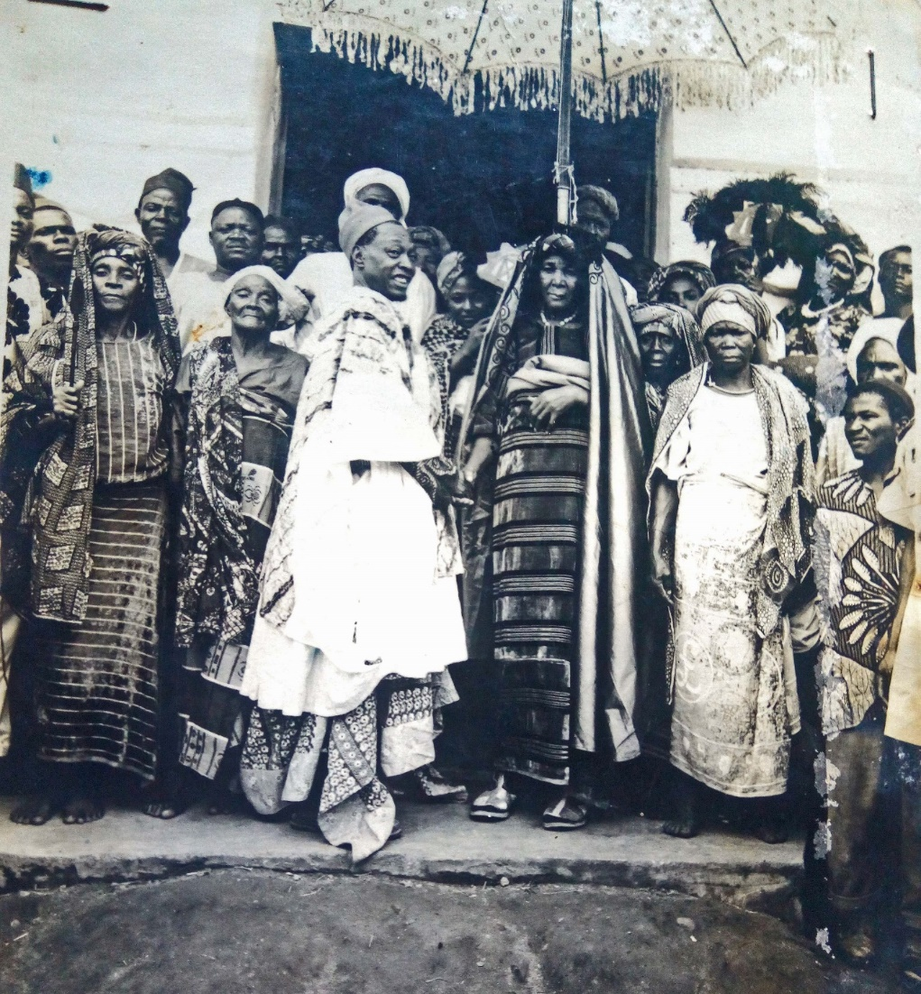
Photograph 5 Ceremonial installation of the Mbala, ‘Father’s sister’ or ‘paternal aunt’ of the Gara, Na-Piya (5th daughter of Sonyonga Garbosa I), 19 June 1959.
In addition to a lengthy list of palace officials and their duties, Garbosa’s History concludes with a series of ethnographic vignettes that concern: traditional greetings and naming, hunting and farming, dances and celebrations, circumcision, and a brief description of the ceremony of Purma at which fealty to the chief was reaffirmed (122-23, see also 147). Many of the same topics are described at greater length in Meek’s chapter about the Chamba for which Garbosa was a research assistant. Given the closeness of the relationship between the two men that Garbosa reported, the similarities cannot be accidental. Drawings and photographs in Garbosa demonstrate the transmission of two Chamba musical and performative complexes, along with their names in Chamba Leko: the six, two-stopped, bamboo lera flutes that perform on ceremonial occasions, and the esoteric seven voma horns that belong to the men’s cults. The same instruments survived the long journey to Bamenda and are performed in the Bali chiefdoms there. Both in the Benue region and in the Grassfields, these instruments are seen as evidence of the Chamba identity of the communities using them despite their having more or less assimilated contingents from numerous peoples over their recent histories. Garbosa’s description of circumcision, although written in the third person, is likely to draw upon his own experience of a ceremony that had disappeared by the time he wrote: not only did the Muslims make their own arrangements but ‘… with all this modern-day progress it is not done any more, the boy is taken to the medical officer for him to do it’ (122). His account of the durbar-like festival of Purma (or Pulma) culminates Garbosa’s selection of ethnographic descriptions and corresponds to a lengthy description in Meek’s account of the Donga Chamba (1931b I: 349-54). The close resemblance between Purma and the festival of Lela in the Bali fondoms suggests that this martial event predates their separation, some elements of it dating back at least to the early nineteenth century (Fardon 2006).
Although baptised a Christian by the Lutheran church, Garbosa’s chiefly position obliged him to be a polygynist. Judging by his spectacles, the photograph below was taken later than Photograph 6, perhaps in the late 1960s or very early 1970s.

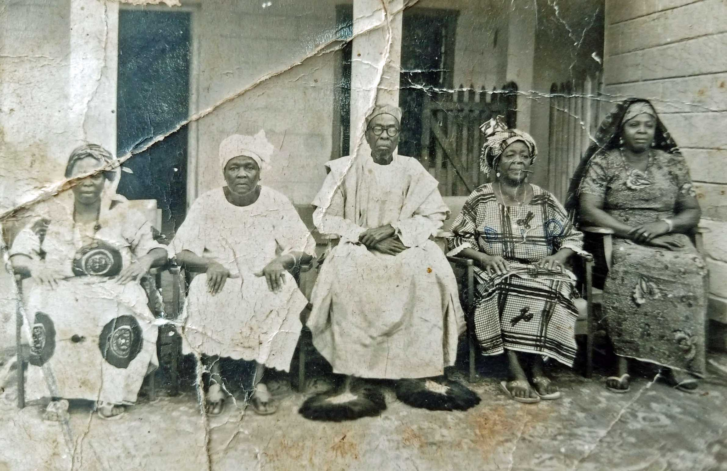Photograph 6 Garbosa II with four of his wives.

In 1956, Garbosa recorded the names of fifteen of his children, characteristically along with the exact hour of their birth. He adds that his father ‘Garbosa I had 150 wives, but the chiefs who followed him, each one had fewer wives and now they are down to 18. They did this for themselves and to fit in with the modern way of doing things’ (156, see also 145). Referring to himself in the third person, Garbosa writes that, ‘On the matter of family, he very much limited the size of his family, they were not many. If it were not the requirement of his country, he would have chosen to have only one wife’ (82).

The translation
The copy of Labarun Chambawa da Al’amurransu on which this translation is based is one of two gifted to Richard Fardon in the mid-1970s. The first was a present from Alhaji Umaru Sanda, who was the kindly Chamba paramount of Ganye in 1976 when Fardon arrived to begin his doctoral fieldwork. An English translation of the History, rather looser than the new translation, was dictated to Fardon by the late Erasmus Hamman Diori, then the Information Officer in Ganye Local Government Area, and written down by him in longhand.

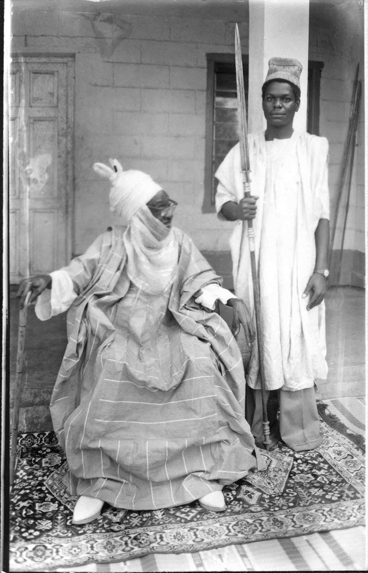
Photograph 7 Portrait given by Garbosa II to Richard Fardon in 1978. Stamped on reverse: D.B. Nyifi Photo Studio, Donga, Wukari [second initial smudged/uncertain]. According to Bobga Bobzom, the location of this portrait can be identified as in front of the Gara’s apartment inside the palace. The spear holder is Prince Garnigha Sambo Garbosa II.
A second copy of the book was the gift of the author, Garbosa II, to Fardon on his one visit to Donga in 1978. That copy, used for the new translation, contains handwritten amendments and corrections in the text itself accompanied by a typed list of corrections, entitled, ‘corrections to mistakes in the typing’. It appears that drawing up both the typed list and the handwritten corrections were undertaken by the author, Malam Bitemya Sambo, himself. These corrections and amendments have been incorporated into this rather closer translation from the original Hausa into English. A handwritten English translation of most of The Family Trees of the Chiefs of Donga, made by Peter Crane when a District Officer in the 1950s, along with a typescript translation of the story of the sixth Gara Donga, were sent by Crane to Fardon and remain in his possession.
As already noted, the author indicates that he started writing this narrative in 1923, expanded upon the text during 1932-33, and revised it in 1956, when his younger brother, M.G.K. Atiku, typed up a manuscript of 345 pages (131). The typeface and layout of the print run would indicate that the book was produced at the Gaskiya Corporation in Zaria, although there is no indication to that effect in the book itself. Although the History had substantial sections added for publication in 1956, it seems likely that the bulk of the text dates from the 1920s with some additions in the 1930s. The Family Trees was started much later and probably completed not long before publication. Certain parts of the earlier narrative were redrafted for inclusion in The Family Trees. For example, the listings of the children of the various Gara Dongas, which are presented rather haphazardly in The History, are organized by age when repeated in the chiefly biographies, suggesting Garbosa made further extensive enquiries about his predecessors. As noted earlier, The Family Trees allows Garbosa to follow a linear narrative, indeed the linearity is integral to the legitimacy of the Donga royal family. Much of the material on the earlier chiefs is similar to that previously presented in The History. The earlier text necessarily has a more complex structure. Its main narrative, as we have shown, pivots around the foundation of Donga by Nubumga Donzomga: what happened before leads to this event, and what happens afterwards stems from it. Additionally, there are substantial descriptions of a variety of customs and performances, based on Garbosa’s own observations and participations. These two aspects of the text are relatively easy to follow, but Garbosa has two further ambitions. The text loops back to earlier stages of the narrative to pick up the histories of sections of Chamba operating independently of what are portrayed as the main settlements (Garkola, Donga and Takum); we have noted this in relation to Suntai, and there are several other examples. Garbosa is also attracted to set piece narratives of memorable events, most notably conflicts over precedence and succession. The entire narrative closes on one of these: the story of the evil courtier Nya Yeba whose killing prepares the succession of Garbosa I who, we should recall, was the author’s father. The placement of the episode, at first sight an afterthought, may perhaps be explained by Garbosa’s sense that his own succession, and hence the histories he was able to compose, were both conditional on Nya Yeba having been thwarted: neither the first nor the last episode to threaten the family tree.
We noted earlier the convergence between Garbosa’s self-understanding as a progressive, and the consensus among British officials that he was an enlightened and modernizing ruler. The phenomena that Garbosa describes as belonging to the ‘time of ignorance’ (zamanin jahiliyya) are various. For instance, he attributed his inability to date relations between the Chamba and the Tiv (48) and the Chamba and the Jukun (39) to a time of ignorance, a particular regret, we may well imagine, to a man who recorded the birth dates of his children not just by day but by their exact time. Earlier forms of governance, also seem to belong to a time of ignorance compared to the standards of Garbosa’s day (104, 108, 127, 156). In most regards, Garbosa saw his present as preferable to the past, it benefited from formal education, more enlightened marriage customs, improved building materials and modern technology. Yet, in other respects, Garbosa was a cautious or conservative progressive, concerned by would-be usurpers of chiefly and other offices, and uncomfortably aware of the potential divisiveness of late colonial party politics (66, 157).
Garbosa’s first language was a Donga dialect of Jukun which, as we have seen, had become the everyday language of the Chamba-led alliance at least as early as the visit of the Pleiad in the mid-1850s. As was the case for Bali Nyonga in Bamenda, the largest of the ‘Chamba’ chiefdoms in Cameroon, although Chamba Leko was supplanted as mother tongue by a local language, it persisted in some of the smaller places. The likelihood is that the most successful ‘Chamba’ chiefdoms, like Donga and Bali Nyonga, also absorbed the most non-Chamba as both cause and effect of that success. It is likely that Garbosa spoke some Chamba Leko, for instance, the instruments he illustrates are named in that language, and he may have delivered a lecture to the Bali Chamba in what is described as Mubako. Hausa must have been an entirely familiar language, along with some English that he learnt through school and through interaction with the apparatus of the colonial state. His Hausa orthography is faultless and his style fluent as might be anticipated of his educational background, with flashes of wit as he addresses his readers and comments upon his own experience. While he seems to anticipate a wider Nigerian readership, for the most part his comments are addressed to fellow Chamba,
… to write the stories of the origins of the Chamba and the affairs of the Chamba so that those who come after and their grandchildren can know something of the origins of their fathers and their grandfathers. So that they know the stories and, if possible, their characters. Some of the stories are about good times some are about hard times, but I am certain that after some years or some time, the stories and those who know the stories of our fathers and grandfathers will be gone from this world unless it has been written down in a book. (66)
Garbosa’s familiarity with Hausa proverbial discourse is evident in his deployment of sayings and proverbs in praise of the town of Donga (80), where he says that no-one has succeeded in any attack upon it – ‘like the wasp’s nest you don’t rub it even in jest …’, although he had previously (79) made reference to, ‘Hamadu, the fourth king of Muri (1861-1869) who founded Gassol and who once attacked Donga from the east and the south and did much damage’. In presenting every Gara Donga in the second part of the book, he employs a repeated sequence for the discussion involving each individual’s history, qualities and his descendants, during which he sets out the Hausa praise epithets (kirari) ascribed to each one. Whether Hausa praise criers were permanently resident in Donga is not clear, the northern tradition included both singers tied to a particular patron along with singers/praise criers who travelled from town to town plying their trade. At one point, Garbosa says of Gara Gargbanyi Bileya,
The Hausas who have the sweetest way with words used to call him Alu (Aliyu) with these praises: ‘Alu, the chief slaughterer, confounder of men, loosener of men’s bowels…’ (136)
In the case of Garbosa I the author says,
The Hausas gave him the name Muhamman and some would say Garbaushe rather than Garbosa. His praise epithets among the Hausa called him: ‘Muhamman the just ruler, everything you have is in the thousands…’ (143)
So, it appears the case that the praises are from Hausa praise singers at the court of Donga, reinforcing the notion of a multilingual community including some Hausa spoken along with Jukun and Chamba. Praise epithets are often dense and sometimes difficult to translate, therefore the original Hausa has been added in square brackets within the English translation for those who wish to consult the original phrase.
When making an English translation of Garbosa’s text, choices need to be made in the light of the implications of certain terms in English as they are generally employed in Nigeria. While the title of the second volume seems straightforward, that of the first might be translated differently. Labarun Chambawa da Al’Amurransu might as well be ‘stories’ as ‘history’ (conventionally tarihi), and ‘circumstances’ or ‘affairs’ are closer translations than ‘customs’. That said, ‘Stories of the Chamba and their circumstances’, makes for an odd-sounding title, whereas ‘History and customs of the Chamba’ at least feels appropriate to the period of writing, and it reflects the sections of his text that Garbosa devotes to a variety of cultural performances.
Garbosa occasionally acknowledges divine providence, for which ‘Allah’ has been retained in the English translation. Although Garbosa was a baptised Christian, he does not generally use the conventional form used by Bible translators into Hausa of Ubangiji. As he puts it, ‘Allah intended me to be a Christian’ (152).
Other terms seem to require more than a single translation. For example, ‘chief’ rather than ‘king’ has been used to translate sarki among the Chamba, but ‘emir’ is used of sarkin Bauchi, because ‘emir’ is the conventional title in northern Nigeria when referring to the Hausa-Fulani states. ‘Chieftaincy’ or ‘chiefship’ has been used to translate sarauta, but ‘palace’ for the residence of the chief, masarauta; ‘titleholders’ has been preferred to ‘aristocrats’ for masu sarauta. The reader might want to bear in mind the greater sense of entailment imparted by the shared root sar- in the set of related terms of the original Hausa.
Garbosa’s transcriptions of the proper names of people, places and geographical features are not entirely consistent, which is understandable given the prolonged period over which he wrote. With the advice from the Gara Donga’s palace, we have adopted a single transcription for some of the more frequently occurring names; any readers interested in the original variation may refer to the Hausa text.
Garbosa was well-versed in the contemporaneous colonial terminology of Region, Province and Division, and he sometimes uses these English terms, on occasions preferring lardi for Province. Independently of such terms, he also uses kasar, ‘the land of’, to refer to areas of land associated with different groups of Chamba or Chamba-related people, and he sometimes delimits them by tracing a boundary line from place to place to define the nature of this or that particular kasa.
Another nexus consists of terms that are not always distinct from one another that are used to describe the construction and locations of settlements. He uses birni (in northern Nigeria generally this would refer to a walled city) to refer to a large established town/city such as the mature Donga, gari for a smaller town, sansani to refer to an encampment or war camp (and runduna to an army), ganuwa to refer to encircling wall/ramparts, katanga to a wall. The frequent splits in nineteenth-century Chamba raiding groups initiated cycles of rebuilding that involved both places and people as allies and followers.
A particular complexity involves the use of terms for groups of people. Garbosa uses kabila, commonly translated as ‘tribe’, to refer to a wide variety of groupings: non-Chamba people, but also groups of Chamba other than Donga, as well as people who are linked with or have, in his view, become part of an expanded sense of Chambaness. A strikingly inclusive example occurs early in his text.
… the Sama and Janga and Nyera are together, similarly Kola, Poba, and Kwasa. And it is the same for the remaining Chamba tribes [kabilu], but for brevity we will just list the names: Ngwuma, Gbana, Shikunkuna, Salkuna, Zaa, Denkuna, Lama, Laga, Pyeri, Dangbalkuna, Kpenga, Zabilkuna, Zamkuna, Nyamkuna, Sobaa, Zagbonkuna, Sarkuna, (Nupabi) Zangani (Zanghani) Gurum, Balla, Darim, Yama, Dakka, Girim, and a number of other small tribes [kabilu]. And then there are Tikari, Pati, Jidu, Lufun, Fali and the remainder with whom we trust to do things together and so they have become our relatives [‘yan’uwa]. (69)
Some of these are patriclan names in the Benue (like Sama, Janga and Nyera), but how Garbosa collected some of the others is obscure. For instance, in Chambaland, -kun suffixed to a clan name, which occurs nine times in the list, would generally denote a matriclan whether in Chamba Leko or Chamba Daka. Lama is Chamba Leko for blacksmith; Gurum is a central Chamba chiefdom, where the Nnakenyare dialect of Chamba Daka is spoken; the Jangani were the inhabitants of the Shebshi Mountains above the central Chamba chiefdom of Sugu; Yama might be a version of Yam-bu, the chiefly patriclan of many central Chamba chiefdoms of the northern Shebshi Mountains. In the event, none of these names recurs in the text.
Garbosa sometimes uses dangi, with its implications of relatedness/relatives/relations, and when he is referring to a group of people this has been translated as ‘kindred’. He also deploys the word zuriya, with its implications of common descent, and he often uses the word in connection with a named group, and in these cases the term ‘clan’, or more narrowly ‘patriclan’, has been used. And he also uses the term jama’a as a general term for ‘people’. While these translational terms try to capture some of this variety, the elasticity of notions of identity was important in the project of continuously reshaping an idea of Chambaness or inclusion in the category of Chambawa. Recall that Chamba language is not the everyday language of Donga, most of the population do not trace a lineage back to Dindin, or Chambaland, and even the chiefs drawn from the Sama clan had mothers of other ethnic origins. When Garbosa reaches out to the Chamba of Bamenda, particularly in Bali Nyonga, he finds that for all their historic commonalities, they are strikingly different. This is noticeable in their colourful dress developed in the Grassfields but interpreted by Garbosa as authentically Chamba, in which form it has subsequently been adopted widely by Nigerian Chamba as a marker of ethnic pride. Giving shape to an inclusive notion of Chambaness, one that extended beyond Nigeria into Cameroon, was an important element of the overall project of Garbosa’s book.
References
Baikie, William Balfour 1856 Narrative of an Exploring Voyage up the Rivers Kwóra and Bínue commonly known as the Niger and Tsádda in 1854, London: John Murray. (Quoted from the 1966 edition by Frank Cass, London.)
Crowther, Samuel Adjai 1855 Journal of an Expedition up the Niger and Tshadda Rivers, undertaken by Macgregor Laird, Esq. in connection with the British Government in 1854, London: Church Missionary Society.
Chilver, E. M. unpublished 1964 (revised 1970) ‘Historical Notes on the Bali Chiefdoms of the Cameroons Grassfields. Two reports to the Bali-Chamba Historical and Cultural Society, Report 1 Origins, migration and composition. Report 2 The Bali-Chamba of Bamenda: settlement and composition.’
Chilver, E.M. and Phyllis Kaberry 1968 Traditional Bamenda: the pre-colonial history and ethnography of the Bamenda Grassfields, Buea: Ministry of Primary Education and Social Welfare, West Cameroon Antiquities Commission.
Downes, R.M. 1933 The Tiv Tribe, Kaduna: Government Printer.
Fardon, Richard 1988 Raiders and Refugees: trends in Chamba Political Development 1750 to 1950, Washington and London: Smithsonian Series in Ethnographic Inquiry.
---- 2006 Lela in Bali: history through ceremony in Cameroon, Cameroon Studies 7, Oxford and New York: Berghahn.
Fremantle, John Morton 1922 Gazetteer of Muri Province (up to December 1919), London: Waterlow and Sons.
Furniss, Graham 1991 ‘Standards in speech, spelling and style – the Hausa case’, in N. Cyffer, K. Schubert, H-I. Weier (eds) Language Standardization in Africa, pp. 97-110. Hamburg: Helmut Buske.
---- 2011 ‘On engendering liberal values in the Nigerian colonial state: the idea behind the Gaskiya Corporation’, Journal of Imperial and Commonwealth History 39(1): 69-93.
Hamman, Mahmoud 2007 The Middle Benue Region and the Sokoto Jihad 1812-1869. The impact and establishment of the Emirate of Muri, Arewa House Studies Series, Kaduna: Arewa House, Ahmadu Bello University.

Hutchinson, Thomas Joseph 1855 Narrative of the Niger, Tshadda, and Binuë Exploration: including a report on the position and the prospects of trade up those rivers, with remarks on the malaria and fevers of Western Africa, London: Longman, Brown, Green, and Longmans. 1961 edition, London: Frank Cass.

Kaberry, Phyllis and E.M. Chilver 1961 ‘An outline of the traditional political system of Bali Nyonga’, Africa 31(4): 355-71.
Kingdon, Zachary 2019 Ethnographic Collecting and African Agency in Early Colonial West Africa: a study of trans-imperial cultural flows, London and New York: Bloomsbury Visual Arts.
Maxwell, J. Lowry 1954 Half a Century of Grace: a jubilee history of the Sudan United Mission, London: Sudan United Mission.
Meek 1931a A Sudanese Kingdom: an ethnographical account of the Jukun-speaking peoples of Nigeria, London: Kegan Paul, Trench and Trubner.
---- 1931b Tribal Studies in Northern Nigeria, two volumes, London: Kegan Paul, Trench and Trubner.
Mohammadou, Eldridge 1978 Fulbe Hooseere. Les Royaumes foulbé du plateau de l’Adamaoua au XIXe siecle (Tibati, Tignère, Banyo, Ngaoundèré), African Languages and Ethnography VIII. Tokyo: ILCAA.
---- 1999 ‘Nouvelles perspectives de recherche sur l’histoire du Cameroun central au tournant du XVIIIe siècle (c.1750–1850): l’invasion Baare-Tchamba’, Ngaoundéré-Anthropos 4: 53–100.
Nyamndi, Ndifontah B. 1988 The Bali Chamba of Cameroon: a political history, Paris: Editions Cape.
Temple, Olive 1919 Notes on the Tribes, Provinces, Emirates and States of the Northern Provinces of Nigeria Compiled from Official Reports, Cape Town: Argus.

Unpublished sources
Documents from the British Library online Endangered Archive Programme (https://eap.bl.uk/project/EAP532/). The dates below are those of the files contained; the currently catalogued reference dates are largely erroneous.
EAP 532/1/24/12 ‘Muri Province – Annual Report, 1908 (No 61)’, F.H. Ruxton
EAP 532/1/32/62 ‘Muri Province Annual Report 1919’, E.G.M. Dupigny
EAP 535/2/4/1/4 ‘Donga District Reassessment 1921’, R.F.P. Orme
EAP 532/1/36/12 ‘Muri Provincial Report 1922’, E.G.M. Dupigny
EAP 532/1/36/6 The Resident’s (J.J. Emberton) Covering Report to ‘Donga and Wukari Division Benue Province Intelligence Report of 1935’, Mr K. Dewar (EAP 532 /1/24/44)
EAP 532/1/24/41 Communications subsequent to the submission of ‘Donga and Wukari Division Benue Province Intelligence Report of 1935’, Mr K. Dewar (EAP 532 /1/24/44)
EAP 532 /1/24/44 ‘Donga and Wukari Division Benue Province Intelligence Report of 1935’, Mr K. Dewar (including Appendix D, Garbosa II)

This work is copyright of the Authors. It is published under a Creative Commons Attribution License (CC BY 4.0 http://creativecommons.org/licenses/by/4.0/) that allows others to share the work with an acknowledgement of the work’s authorship and initial publication in this journal.
Cette œuvre est mise à disposition selon les termes de la Licence Creative Commons Attribution (4.0 International https://creativecommons.org/licenses/by/4.0/deed.fr) qui permet à d’autres de partager le travail avec une reconnaissance de la paternité du travail et de la publication.

We are grateful to Isa Sa’ad, Raymond Boyd and Richard Fardon’s long-time collaborator, who put us in touch with Bobga Bobzom of Donga, grandson of Bobzomya (the brother of Garbosa II). As well as providing images from the photograph album of his late uncle, Yebduya Atiku (Garkulyebiya, d. 2020), and being a constant correspondent, Bobga Bobzom also liaised on our behalf with the Donga Palace and the Gara Donga, HRH Sanvala Varzoa Shimbura, regnal title Gargbanyi II, to secure permission to publish the English translation of Garbosa II’s book. Karin Barber’s incisive questions from a close reading helped us to improve this essay. Jude Fokwang and Ian Fowler assisted our efforts to identify Photograph 4.
Numbers in brackets without further information refer to the translation into English made by Graham Furniss that is freely available in this issue of Vestiges, along with a reproduction of the original full Hausa text.
By the 1919 Muri Province Annual Report, E.G.M. Dupigny listed SUM schools at Ibi, Wukari, Donga, Langtang and Lupwe teaching religion, education and medical subjects. Of 145 pupils, 44 were girls.
The wide distribution and variety of Chamba caused confusion in early reports. Even before the nineteenth century, Chamba spoke two mutually incomprehensible languages, and these differences multiplied as the migrant groups became multi-ethnic through incorporating others en route and assimilating them (or being assimilated by them) to variable degrees. Olive Temple, in trying to synthesise the reports of different colonial officers, presents an authoritative-sounding summary that is utterly muddled and best disregarded (1919: 79-84). The dating proposed for Chamba migrations has been confused further by claims of eighteenth-century raids by a group which took a more direct westerly route across the Shebshi Mountains, thereby arriving in the Benue plains ahead of the groupings discussed by Garbosa; but traditions in Chambaland suggest that this movement, like the others, occurred in the context of the Adamawa jihad (see Fardon 1988: 96-100).
An online ‘List of Historical Events in Donga’, last updated in 2010, offers the precise information that on ‘5-08-1933 Bitemya Sambo, Gara Donga published a book titled “Labarun Chambawa da Al’amuransu”’. Dating to the day is reminiscent of Garbosa’s own practice. Ibrahim Usman (‘official government reporter’) is noted as author http://dongaevents.blogspot.com/. Bobga Bobzom (personal communication) clarifies that Ibrahim Usman was from the Kentu (Ichen) people and related to his own father Saidu (Garsheya) Bobzom. Mahmoud Hamman (2007: 193) references a manuscript copy of Garbosa’s History in Professor Abdullahi Smith’s Collection, Arewa House, Kaduna that he dates to 1923, suggesting that the earliest version of the history may survive, although we have been able to verify this ourselves.
Three files in the British Library, all from 1935, deal with this affair but at the time of consultation had been wrongly catalogued as 1947, 1925 and 1938. EAP 532/1/24/41 contains the communications following on from the submission of a Donga and Wukari Division Benue Province Intelligence Report of 1935 authored by Mr K. Dewar which is archived as EAP 532 /1/24/44 (and includes Garbosa’s four-page contribution as Appendix D). The Resident’s (J.J. Emberton) Covering Report to the Intelligence Report is archived as EAP 532/1/36/6. Under these circumstances, it seems least confusing to refer to them by the names of their authors.
This map has been extracted from a larger original entitled ‘Northern and Southern Nigeria’ which was published by the War Office in 1910 and printed at the Ordnance Survey Office, Southampton, in 1913. It was included in a hardbound copy of the Annual Reports, Northern Nigeria 1900-1911. The scale of the original map was 1 cm to 20 kms. Because this version is enlargeable, we cannot express scale in the same scalar terms, but as an indication of distance: a straight line between Donga and Takum would measure 60 kms.
It is probable that Garbasa died earlier than 1885. Fremantle notes that ‘Galbarni’ (Gargbanyi in Garbosa’s History, the son of, and successor to Garbasa) was signatory to a treaty with the Niger Company in 1885, which would need to have coincided with the year of his accession to support Garbosa’s calculation. While this is not impossible, it seems fortuitous and, writing at a time when the death would have been well within living memory, Fremantle proposes regnal dates of 1852-77 for ‘Donga’ (i.e. Nubumga Donzomga). The end date of the reign is at least plausible, but the accession date proposed conflicts with the eyewitness reports of the chief cited as Donzomga’s father, Garkiye, having met the Niger-Benue expedition in 1854, as described below, and having died only after Donga was founded around 1860 (Fremantle 1922: 41). It is likely that Garbasa ruled in the 1860s and 1870s, but whether and if so by how many years his reign extended earlier into the 1850s and later into 1880s remains guesswork. Garbosa’s informants’ attribution to both Garkiye and Garbasa of identical reigns of forty years feels too neat, as if ‘forty’ was used to mean ‘long’. Even in principle, a father and son with combined lengthy reigns of eighty years would be unusual. Chamba Leko and Chamba Daka languages both count in multiples of twenty, so that ‘twenty twice’ may signify a long duration. We return to this conundrum below.
The version of history that Fremantle records from Takum has the effect both of relating Takum and Donga, and of arguing the ascendancy of the former. According to this, the raiders left Chambaland in two sections: one led by Garuba, and the other by three sons of Garuba’s brother, Gando, who had been killed by the Fulani before the Chamba quit their homeland. Garuba was also killed under unspecified circumstances in the vicinity of Takum, while Galboshi (Loya Garbosa in Garbosa’s History) was killed in a dispute with Kumboshi, son of Gando, whose successors founded Takum (Fremantle 1922: 40).
The chief Gamie, born Dinkomiya, left Gildu and became first chief of Kungana. Later he re-joined Garkola and went on to establish the town named after him.
Takum sought a flag from Sokoto under Chief Yakubu I who died in 1882. His successor, Boshi II, was deposed and exiled for slave trading by the British in 1907, his brother being deposed on the same grounds in 1914, after which chieftaincy passed from Chamba to Kutep hands with the accession of Amadu (Fremantle 1922: 40). This example of the British passing power from Chamba hands was a worrying precedent for Garbosa.
While Garbosa described Doo Shimbura Garkiye and Nubumga Donzomga Garbasa as solicitous father and dutiful son, presenting the latter as successor to the former, some aspects of the text suggest a more complex relationship. Shimbura left Nubumga Donzomga behind in Garkola and, in effect, seems to have ransomed him; all three of the eye-witness reports from the Pleiad indicate two distinct settlements, and Hutchinson calls the rulers ‘brothers’, though little store can be put by this comment, based on scant knowledge, which may have been only a figure of speech. On both the occasions, when Nubumga Donzomga leaves to gain a flag, he does so without Garkiye. In relation to Suntai, we again find that Garbosa indicates a difference of opinion, in that it is the son and not the father who behaves as aggressor. A Suntai account collected from a member of the royal family, Zakariya Gargbanyi, by Roger Blench almost forty years ago amplifies the difference claiming that Doo Shimbura had been expelled from Gangkwai for attempting to usurp the throne, but that his group was welcomed in Suntai which was nonetheless attacked by his son Nubumga Donzomga (Blench 12 April 1984). The forty-year reigns that Garbosa attributed to both father and son would be difficult to accommodate within other known events if they were sequential. While none of this is an impediment to accepting their father-son relationship, the fractious quality of the relationship between the two leaders is a running if submerged theme of accounts which also suggest distinct,or at least distinguishable, followings at some points. So, their reigns may in considerable part be contemporary rather than consecutive.
Nyamndi (1988: 163 fn3), attributes this information to a letter in 1985, but Garbosa died in 1982 so it is unclear who was the sender.
It is unclear from Garbosa’s account whether both lera and voma performed in sight of women in Donga. The latter doing so would have been impossible in the Chamba homelands (119-20, 123-24, 138-39).
This copy of the book has been donated to Roger Blench’s research library in Cambridge.
The rules for roman script Hausa spelling had been formulated in 1916 by Hans Vischer and implemented consistently by Rupert East as Superintendent of the Literature Bureau in the early 1930s at the Gaskiya Corporation (publisher and printer) in Zaria. For a discussion of Hausa standardization see Furniss (1991) and for Rupert East and the Gaskiya Corporation see Furniss (2011).

